Designated Mental Health Lead Portfolio
(Level 4 Certificate in Mental Health Aware Leadership (Education Mental Health Lead))

Name: Anonymous

Instructions
This is the portfolio to reflect on your journey as you apply the learning in your setting. You are assessed on your application of the learning to your workplace, your development and your self-study of topics related to your work. Aim to write 100-250 words in response to each point.
Please complete the portfolio questions based on your experience. Only once you have done this, then complete the cross-referencing in the Evidence Tracking.
Please complete and return to info@rootofit.com within six months of the commencement of your programme.

Personal Details
First | X | Last | Y
Email | Z
Employer
☒ I confirm that the assignment submitted is my own work
☒This is a resubmission
Signed:

Date: 14.09.22 Resubmission 10/02/2023

Contents
Instructions 2
Personal Details 2
Self-study 3
Part 1 Understanding the Role 12
Part 2 Ethos and Culture 19
Part 3 Leadership and Management 24
Part 4 Pupil Voice 27
Part 5 Parents, Carers and the Community 29
Part 6 Staff Support 31
Part 7 Mental Health Interventions 42
Part 8 Targeted Support 52
Part 9 Curriculum, Teaching and Learning 55
Evidence Tracking 58

Self-study
Question: 1 How have you selected your topics and the relevance to your workplace?
Unit: Researching a Mental Health Leadership Topic | Assessment Criterion: 1.1
Being relatively new in post as Whole Academy Mental Health Champion at the Academy there are many Self Study topics to choose from. I was keen to develop a range of priority areas such use Referral Systems, Mental Health Universal Screening tools, working with parents/families, Mental Health education within the curriculum and staff wellbeing. After completing my setting audit and reviewing current provision it was clear that through developing new and more effective signposting tools for all stakeholders, I will then be able to effectively navigate the other areas of my development plan through being more informed and having quality assured the resources available to the academy.
The topic that I have selected is ‘Signposting Mental Health Support’. Specifically, how to utilise technology (social media, websites and apps) as tools to support positive mental health and well-being for all stakeholders.
I have selected this topic as my focus for self-study for several reasons, firstly as the Whole Academy Mental Health Lead at a very large secondary academy I want to discover a way of destigmatising Mental health, promoting positive wellbeing and signposting support to all 1700+ students. Secondly, as a mother to two secondary school aged children I am aware of the time spent by young people on their devices. In addition to this, from our experiences of using technology throughout the Covid 19 pandemic we have discovered that despite technology having a bad reputation it can be used to improve social connection, build a sense of community and access support.
Our academy stakeholders responded very well to the transition to online learning and our Executive principal social media twitter account is very popular with other 2000 followers. I believe that ‘Signposted’ using virtual, online, and social media accounts will be a successfully and popular choice for our academy setting.
Identifying mental health and wellbeing resources that meet our academy needs as well as resources, provisions and services that are accessible via stakeholders directly through self-referral are a priority. Since the Covid 19 pandemic we have found that students and staff are overwhelmed with the vast number of resources available, so another priority is ensuring that all signposting points to quality assured and valuable provisions.
I intend of developing new signposting systems that point to information of the following types:
- Support available within the academy
- websites and web chat
- telephone/text helplines
- social media contents and apps
- face-to-face services including support groups
- learning opportunities.
- Physical wellbeing opportunities

Question: 2 List the resources and reference materials that you selected. Ideally you should use a Harvard referencing system and sort your references according to the author.
Unit: Researching a Mental Health Leadership Topic | Assessment Criterion: 1.2
Books and Reference Materials
Glazzard. J. and Bostwick, R. (2018) Positive Mental Health: A Whole School Approach. St. Albans, Hertfordshire. Critical Publishing Ltd. Illustrated edition.
Glazzard. J. and Bancroft, K. (2018) Positive Mental Health: Meeting the Mental Health Needs of Learners 11-18 Years. St. Albans, Hertfordshire. Critical Publishing Ltd. 1st edition.

Websites
Anna Freud https://www.annafreud.org/
Art of Brilliance https://www.artofbrilliance.co.uk/
Beat Easting Disorders https://www.beateatingdisorders.org.uk/get-information-and-support/
Childline https://www.childline.org.uk/get-support/
Community 360 https://www.community360.org.uk/
Essex Youth Service https://youth.essex.gov.uk/young-people/
Kooth https://www.kooth.com/
LifeWorks https://wellbeing.lifeworks.com/uk/
Linktree https://linktr.ee/s/discover/share-content/
Mermaids https://mermaidsuk.org.uk/young-people/
Mind https://www.mind.org.uk/information-support/for-children-and-young-people/understanding-mental-health/
Stem 4https://stem4.org.uk/schools/
Teenage Sleep Hub https://teensleephub.org.uk/
The Mix https://www.themix.org.uk/
Winston Wish https://www.winstonswish.org/supporting-you/
Young minds https://www.youngminds.org.uk/

Social Media accounts

Action for Happiness. Instagram https://actionforhappiness.org/
Anna Freud. Instagram https://www.instagram.com/afnccf/
MHST Alliance. Instagram https://www.instagram.com/alliancemhst/
The Mix. Instagram https://www.instagram.com/themixuk/

Publications
Department for Education. Counselling in schools: a blueprint for the future. (2016)
Department for Education. Online Harms White Paper. (Updated 15 December 2020)
Department for Education. Promoting and supporting mental health and wellbeing in schools and colleges. (Updated 4 July 2022)
Department for Education. Mental health and behaviour in schools. (Updated 12 November 2018)
NELFT EWMHS (Emotional Wellbeing & Mental Health Services) Mid and South Essex Schools & Colleges. Mental Health Support Team Partnership Agreement. (Reviewed and updated 21/1/2021)
Transforming Children & Young People’s Mental Health Information Pack & Checklist

Apps
CalmHarm
ClearFear
CombinedMinds
LifeWords
MyJourney
MoveMood

Video Media
Brown, Dr Brené "An RSA animation on Empathy" with https://youtu.be/1Evwgu369Jw
Hall, J. Ramage, A (2021) Live Life Connected https://youtu.be/pOW6y_aAVbI
Mid and South Essex Integrated Care Systems. (2021) MHST Secondary School Animation https://youtu.be/1SzAF7r-kaY

Question: 3 Present the main findings of your research and link each to people’s wellbeing.
Unit: Researching a Mental Health Leadership Topic | Assessment Criterion: 1.3
Over the course of my training and research it has become evident that there are many resources available to support the ‘Signposting Mental Health Support’. It also became evident that many organisations are utilising technology (social media, websites, and apps) as tools to support positive mental health and wellbeing for their stakeholders. I will attempt to summarise the main findings of my research:

Infiltrate social media feeds: Through my training I have identified many large mental health organisations that use social media to reach their target audiences, and target audiences favour different social media platforms. Young People specifically Gen Z (Born 1997-2005) are more likely to use Instagram whereas Parents specifically Millennial (Born 1983-1996) and Gen x (Born 1964 -1982) are more likely to use Facebook and Twitter. This means that if I wish to target support via social media, I can use the appreciate platform to best meet the audiences of students, staff, and parents. Also, through this research I developed an excellent catalogue of social media accounts that effectively signpost, and these will support me in my role.

Signposting does not necessarily mean engagement: Although signposting in essence is a simple task, my findings identified the difficult task is getting stakeholders to access the support being signposted. I found that there are many contributing factors to this which could include accepting that they need support, the associated stigma with mental health and thinking the support will not be helpful. I will ensure that to address these concerns in my signposting by ensuring support is aga-appropriate, valuable, and easily accessible. I will utilise student voice/ student wellbeing ambassadors so that students can see how effective support is for their peers. Through our whole academy approach to destigmatise mental health we will ensure that through our academy vision, displays, assemblies, lessons, and website we continue to promote openness and of the mental health.

Digital mental health tools are effective: It was clear in my research that digital mental health and wellbeing tool work. They can improve employee’s performance and mental health; they are engaging for young people and therefor have a greater success rate. In recent years there has been an increase in digital devices, smartphones/watches, and fitness trackers, this has created more opportunities for technology to be developed to support wellbeing, high investments from big originations have resulted in an influx of quality websites, online toolkits, apps, eBooks, podcast, social media platforms etc.

Digital tools can play a useful role in addressing mental-health challenges in and outside of the academy. These finding have directly influenced the production the follow digital tools I have create:

Question: 4 Describe how the outcomes of your research links to your role.
Unit: Researching a Mental Health Leadership Topic | Assessment Criterion: 2.1
The outcomes from my research and self-study have not only linked to my role as Whole Academy Mental Health Campion but that have supported an improvement to the provision I can offer to stakeholders at the academy.
Within my role as Whole Academy Mental Health Champion the development of staff is critical to ensure that the whole academy provision can be developed. The research that I completed enabled me to discover tools, strategies, and resources that will enable staff to support their own mental health so that they can look after themselves. This was evident in my research around Education Assistance Programmes where I discovered the LifeWorks program which is ideal for our staff in our setting. I was also able to direct the Director of HR to create an Academy HR linktree were mental health and wellbeing signposting will increase and promote awareness to all school staff. These linktree resources have been added to staff email signatures and posters around the academy via QR codes on posters.
Another key aspect to my role is the development of Parent/Careers engagement and through my research I have identified support and the signposting of relevant evidence-based resources for parents, families, and carers so they can develop skills and strategies to support both their child and them. This was especially evident in my experience on the Anna Freud website and Young Mind website where they offer concise toolkits for parents as well and brief information leaflets which I can print and place in our Academy Family Wellbeing Hubs.
This self-study has enabled me to see the positive uses of technology to support the wellbeing of students, I hope to develop this area of my role to include coproduction with our attendance and behaviour teams so that we can utilise technology for our student that struggles to make it into the academy. Including vertical wellbeing lessons/webinars/videos/ podcasts and virtual learning robots.

Question: 5 Complete the following table of actions from your research.
Unit: Researching a Mental Health Leadership Topic | Assessment Criterion: 2.2, 3.1, 3.2
Please note it is unlikely that you will have completed all actions, however you need to evidence that you have carried out at least one and the perceived impact on wellbeing for that action. If you are not in role yet, we recommend including actions that you can be undertaking now in preparation (e.g. further research, producing information, preparing documents).
Key finding | Planned actions  Criterion 2.2 | Actions completed  Criterion 3.1 | Impact of these changes on others’ wellbeing  Criterion 3.2
Student focused signposted social media  Need to develop links to external support service and other agencies: Emotional Wellbeing and Mental Health Service (EWMHS), Mental Health Support Team (MHST), Community Mentors & Children and Young Person Practitioners via Essex Child and Family Wellbeing services.  Need to development of clear signposting of a range of local support services and voluntary sector organisations to all Stakeholders including parental engagement. | Develop a Family Wellbeing Instagram account – keeping updated with mental health support, resources, and information.  Create signposting on student cards so that every student as assess to these accounts via QR codes and is aware of the internal academy support available | Complete Created Linktree page with the quality assures external support provision available  Ongoing: Update page with age-appropriate content, sharing student achievements to support the development of shared ethos and values.  *insert  Complete 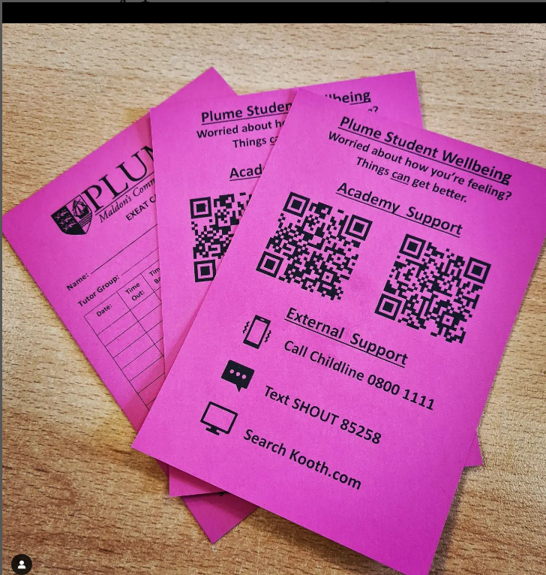 | Stakeholders will be able to easily access support, information, and toolkits online. This will support Academy stakeholders in being equipped to be agents of their own mental help and support others.
Staff focused digital resources to support wellbeing | Change of Education Partnership program to a provision with a digital app. | We have commissioned a new Employee Assistance Programme called LifeWorks for all colleagues and their families to use with a revised telephone number of 0800 169 1920.  This replaces the programme that was previously on offer with Education Support Partnership and is an updated app based and internet-based service for staff to log on at their convenience.  . 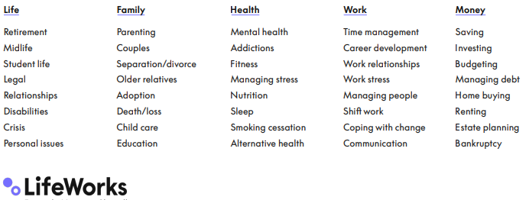 | Review and monitoring data will be available to identify the number of staff that are accessing the resource.  Stakeholders will be able to easily access support, information, and toolkits online. This will support academy stakeholders in being equipped to be agents of their own mental help and support others.
Accessibility and usability of resources | Invest in a page turner software so that resources on the academy website are easier and more enjoyable to access | Product purchased and training for key staff on how to use it given.  Next steps are to use this software on wellbeing toolkits which will be available on the Academy Family online Wellbeing Hub | Stakeholders will be able to easily access support, information, and toolkits online. This will support Academy stakeholders in being equipped to be agents of their own mental help and support others.
Development of Wellbeing Hubs at each campus & online | Develop Academy Family Wellbeing Hubs, which are community resource for all students, staff and families of the A Academy, X Community Academy. Information and guidance can be accessed for those that are: worried about the wellbeing or mental health of a child, family member, friend, or colleague, or seeking wellbeing support and positive wellbeing ideas for themselves. | The physical Hubs are located at MRC in room 1 and FRC on the SSC corridor next to the accessible toilet.  Next steps are to create an online version of the wellbeing Hub available via the academy website.  The activities will consist of:  •Wellbeing drops in and check-ups for individual year groups  •MHST Drop-in sessions (To be confirmed)  •Young careers group meets  •Antibullying Ambassador base  •Academy Pride group meets & LGBT+ support  •Wellbeing boost activities  •Staff Wellbeing base (Afterschool)  The Hubs will act as bookable bases for targeted support/intervention sessions.  •School Councillor sessions  •MHST Sessions  •LGBT+ mentoring  •SEND Breakfast Hub  •School Nurse Sessions  •Parental meetings  •Community Mentors  Contents of Hubs  The Wellbeing hubs will consist of different zones:  •Toolkit resource stations (Infographics & resources to support wellbeing)  •Laptop stations (for students to use to access online support Kooth/Shout etc.)  •Signpost displays, Motivational posters, available support, upcoming events)  •Quite comfortable space for wellbeing conversations  •A desk area for staff to use to write referrals etc. | Stakeholders will be able to easily access support, information, and toolkits online. This will support Academy stakeholders in being equipped to be agents of their own mental help and support others.

I have Ragged these actions to indicate the progress I have made in relation to these action’s: Green = Achieved/Complete, Yellow = Making good progress towards target, Red=Not complete

Part 1 Understanding the Role
Question: 1 Why is it important that a mental health lead contributes to culture and ethos?
Unit: Supporting the Wellbeing in own Organisation | Assessment Criterion: 1.1
Mental health and wellbeing must be the golden thread through every aspect of student, parent and staff interaction, intervention, training, and support. Tying everything together from achievement to safeguarding.
A mental health lead has a significant impact on the culture and ethos of their educational setting. From the brief experience I have had within the Whole as Whole Academy Mental Health Champion the ever-developing Mental Health agenda is the golden thread that not only weave its way into all areas of the academy but also links them to make them stronger.
My role is to oversee and monitor the provision of mental health and wellbeing strategies, resources, internal and external interventions for young people ensuring the full inclusion of all disadvantaged and marginal groups for example Young Carers, PPG, SEND etc. This strategic leadership role relies on the mental health lead effectively working with others within the academy to develop and deliver a whole school approach to mental health. This in turn will support and develop a culture/ethos where mental health is prioritised, interventions are effective and behaviours across the academy are developed to de stigmatised Mental Health.
I believe that it is important for me in my role to contributes to the culture and ethos so that our ‘Academy Family’ are well equipped to be the agents of their own Mental Health. I hope to achieve this through continuing to line manage our academy counsellors, oversee the MHST provision, meet frequently with faculty leaders and pastoral teams to ensure curriculum provision and MH referral systems are updated and effective. I am also well equipped to make significate change through my links with our Senior Leadership Team and my lead role in the Personal Development/ Tutorial provision at The Academy.

What is our intent for the Culture at Academy?  Culture (noun) the beliefs, values, behaviour, and material objects that constitute a people's way of life | What does the right Ethos feel like for Academy Students and Staff?  Ethos (noun) The character or fundamental values of a person, people, culture, or movement.
The Academy Family not only acknowledges difference, but activity celebrates it. This in turn supports positive behaviours for learning, successful relationship building and provides an emotionally secure and safe environment that prevents any form of bullying or violence. | Students and Staff feel a sense of belonging and enjoying being part of the ‘Academy Family’.  A community Academy
Actively part of the local community | Achievements both inside and outside of the academy are celebrated via internal and external sources.

Question: 2 Identify some the personal qualities required to be a mental health lead and why each is important.
Unit: Supporting the Wellbeing in own Organisation | Assessment Criterion: 1.2
Please find below an outline of some of the personal qualities, professional attributes, and skills the Mental Health Lead requires:
Passion (Personal Quality): I believe that Passion is the most important personal quality that a MH lead requires to be successful in their role. Passion ensures committed is given to a cause and in turn supports the achievement and wellbeing of young people. Passion encourages the MH led to be always striving for better provisions, knowledge, and resources. I believe that my own passion for inclusive education is evidenced in my enthusiastic approach and positive relationships with all stakeholders. Passionate people are driven by professional development opportunities and some recent CPD opportunities I have taken on include further reading around ‘Positive mental health’, Attending Mental health training (Place2be & Root of it), Researching cutting edge up to date practice including the use of technology to support effective signposting and taking a collaborative approach with other educators, via webinars & conferences.
Communication (Skill): To make effective change at a whole academy level it is essential that the MH lead is a very good communicator. Ensuring written communication with all stakeholders is professional, this has been evident in my creation of a whole academy mental health policy. The ability to adapt not only their dialogue content but vocal skills, such as tone, pace, and volume, in their spoken communication supports effective relationship building and information sharing with all stakeholders. This has been evident that I have developed effective communication skills in my effective delivery of assemblies, parental forums, information evenings and in my ability to have difficult conversation about sensitive topics at a one-to-one level.
Approachable (Professional Attribute): Being approachable is critical when developing a collaborative culture to mental health. Students, staff, parents, and trustees need to know that you are willing to listen, answer questions and support them in their roles. I pride myself on being a positive team player, coach, and motivator and this has supported me in my role as MH lead to develop successful working relationships with SEND, Pastoral, Extended partnerships, Faculties, Parent/Careers. Being approachable is more than just listening it is also about upholding professional integrity, being sensitive and discreet.
Organisation (Professional Attribute/Personal quality & Skill): Organisation encompasses so much more than just being organised, which is an import personal quality for any leadership role. MH Leads need to be plan, deliver, and review the whole academy mental health provision, so developing skills around time management and prioritising are essential.
In previous roles as ‘LGBT+ Stonewall Champion’ and ‘Head of Year’ I have a proven track record for my passion, approachability, effective communication and organisation, these transferable skills supported me to develop the whole academy LGBT+ agenda in line with statutory guidance and benched mark by Stonewall values. Construct a reflective and robust development plan. Delivered whole academy staff training. Drive a change in culture where stigma round LGBT+ issues has been reduced along with bullying and difference is celebrated. Develop an in-depth understanding of the academic, social and welfare demands on young people from a pastoral leader role. I intend on utilising these personal qualities, profession attributes and skills to ensure I am a successful Whole Academy Mental Health Lead.

Question: 3 Identify your own developmental needs and your plan to be effective in the role
Unit: Supporting the Wellbeing in own Organisation | Assessment Criterion: 1.3
It is essential that mental health leads are reflective of their own development needs, not only so that the provision they are providing is equipped to meet the needs of their setting but also so they role-model effective self-development skills to school staff and students. I feel that SMART targets are an appropriate way I which support personal development needs, and these must be: Specific (simple, sensible, significant), Measurable (meaningful, motivating), Achievable (agreed, attainable), Relevant (reasonable, realistic, and resourced, results-based), Time bound (time-based, time limited, time/cost limited, timely, time-sensitive).
Development Need | Smart Target
Development Needs 1: Identifying and facilitating appropriate training for staff. To develop my knowledge and understanding of Safeguarding, especially in when, how and who to refer to. | SMART Target: By September 2022 complete the Level 2 Designated Safeguarding Lead training which equates to 7 hours of CDP. (Complete 02-08-22)
Development Needs 2: To develop my knowledge and understanding of mental health monitoring and measuring strategies | SMART TRAGET: Using research from Anne Freud create a student survey based on the Warwick and Edinburgh and SDQ surveys to track monitor and measure student wellbeing termly.
Development Needs 3: Promoting my own physical & mental health through positive wellbeing strategies. | SMART Target: To lead by example by stopping every day to have a lunch break in the staffroom, using this time to connect with colleagues and allow time to rest during the working day.  SMART Target: To begin open water swimming, developing skills through coaching session once per week and completing a nonstop 2-mile distance open water swim by September.
Development Need 4 With subject leads, developing a cross curricular approach to mental health and wellbeing. | SMART To meet with Faulty leads to support the implantation of Cross curriculum mental health for Academy family Wellbeing Week 2022/2022
Update Sept 2022 – I have Ragged these Smart Targets to indicate the progress I have made in relation to these development needs: Green = Achieved/Complete, Yellow = Making good progress towards target, Red= Target not complete
See Attached Personal Skills Audit
Please attach your completed organisation audit (exported from the website or completed Word version) – Assessment criterion 2.1
See attached Setting Audit A Ollett.docx
Attach your setting's plan to develop, implement and sustain a whole school or college approach to mental health and wellbeing – Assessment criterion 2.2
See attached Mental-Health-Action-Plan A Ollett.docx

Question: 4 What impact/changes have you made to the whole-setting, or are you planning to
make, with regards to mental health and wellbeing. For those that have been implemented, what
has the impact been? (Please provide at least two examples.)
Unit: Supporting the Wellbeing in own Organisation | Assessment Criterion: 2.3
Below is a sample of what I have implemented:
- Academy Family Wellbeing week each term
- Diversity and celebration assemblies and tutorial sessions
- A wellbeing Hub at each campus
- Posters/displays& inclusive lanyards
Based on evidence from the Summer Term Student Wellbeing Survey the impact of my whole academy approach can be evidenced in the following statistic in relation to mental health, diversity and antibullying initiative run during that term:
90% of students Strongly Agree or Agree to the statement ‘I know know who to speak to if I have a concern around my health and wellbeing’. The most useful part of this question was that due to the survey not being anonymous we were able to direct the pastoral teams to seek out those that had disagreed with the statement to ensure that in future they know who to talk to.
79% of students Strong Agree or Agree to the statement ‘I believe the academy is committed to celebrating diversity’. The work we had been doing on LGBT+ inclusion was commended however student wanted to see other marginal groups in our celebrations, awareness days and assemblies.
60% of students Strongly Agree or Agree that ‘The academy contributes positively to the health and wellbeing of all students’ Again, we were able to address concerns from those students that had negatively sored on this survey. This was very productive as it gave an opportunity for those students to be listen to in a 1:1 learning conversation with their assistant head of year. Reassurance was offered and they were able to voice concerns around the wellbeing of others and themselves.
As a baseline assessment of the provision, we as an academy are offering, I am incredibly pleased with the positive feedback and now this gives us a starting point to address the concerns to raise the outcomes in the next survey. The overall impact is that we are now in a much better position as we clearly see the areas for improvement.
My future aim to develop the cross curricular approach towards mental health, this will be via coproduction of the Personal Development Curriculum with students and key colleagues to ensure that it is age appropriate, utilises up to date knowledge and information and enables students to effectively improve their mental health and wellbeing through practical strategies and tools. This is a big project, so I have saved this for the new academic year, my first year in post was about quick wins, visibility and destigmatising mental health.

Question: 5 How have you worked with others/used others i.e., colleagues/support networks; to
sustained and improved your approach? (Give at least two examples.)
Unit: Supporting the Wellbeing in own Organisation | Assessment Criterion: 3.2
I have been extremely fortunate to have had very positive experiences with other colleagues within the academy. Although I am not on the senior leadership team I have the full support of the Executive Principal, Heads of Academy and extended SLT. I have been given the autonomy to make decision at an SLT level and believe that our academy vision prioritises mental health for all stakeholders. I meet regularly with the SLT and termly with our academy Trustees who are a pleasure to work with as they offer rigorous monitoring of the work we do as an academy and are keen to learn more about the Mental health agenda. I recognise that I am very fortunate in this position and for networking with other mental health lead I appreciate that this is not aways the case in other settings.
I work very closely with the safeguarding teams, and we meet weekly to discuss mental health referrals, review current cases and advise as to the best routes of support for individual cases. We review discharge letters from external provisions to ensure reasonable adjustments can be made to support the wellbeing of these struggling with poor mental health. We log and record actions on our My concern platform so that a clear record is kept of interventions and referrals.
Within my role there is a need to bring others along with you on the mental health awareness journey, and an example of this is when we have run the Academy Family wellbeing weeks. These weeks are in line with national awareness campaigns such as Children’s mental health week delivered by Place2be, world mental health day and the national mental health awareness weeks. I utilise staff to support these key messages in the following ways, working with teachers to support the creation of lesson starters on a given theme, collaborate with Heads of year to ensure that the assemblies are delivered in a bespoke was for their year groups acknowledging any typical behaviours or themes for them. Supporting our 60+ Form Tutors to deliver tutor sessions by creating resources and running training session.
As previously mentioned, my future aim to develop the cross curricular approach towards mental health. Working with faculty and subject leads to ensure that our Curriculum Plans are developed with mental health in mind. By developing the cross curriculum mental health contend we will be able to achieve an outcome where mental health is fully destigmatised within out setting.

Question: 6 What is the role of a mental health leader in your setting?
Unit: Meeting the Responsibilities Placed on an Education Mental Health Lead | Assessment Criterion: 2.1
The Mental Health Lead Role at The Academy have been developed in a bespoke way to support the needs of this very large Academy. The Academy is unique in that it is set of two campuses with year 7/8 in our A Road Campus and year 9,10,11,12&13 in our B Road Campus. We are the third largest academy in Anonymous. When developing the role of the Mental Health Lead at The Academy in May 2021 we were keen to establish a ‘Champion’ role
What is a Champion?
‘A person who vigorously supports or defends a person or cause.’ Oxford Languages.
‘A person who enthusiastically supports, defends, or fights for a person, belief, right, or principle.’ Cambridge Dictionary.
The role of Whole Academy Mental Health Champion was developed. Reporting to the Assistant Vice Principal for Inclusion, the intent was for this role to develop a comprehensive framework and associated development plan that will enhance the current understanding and practice of assessing and supporting students’ mental health and wellbeing. The Whole Academy Mental Health Champion works in partnership with the Director of HR on all Staff Wellbeing provisions.

Personal Qualities
Hardworking, enthusiastic and have a high level of commitment and ability to focus on fostering the teaching and learning and personal development of Year 7-to-13-year students.

Responsibilities of the Post Holder
- to work alongside the academy’s pastoral and SEND teams in matters directly relating to students’ mental health and wellbeing
- to work alongside the academy’s many external partners in matters directly relating to students’ mental health and wellbeing
- to support the academy’s faculties and their respective staff to champion our students’ mental health and wellbeing
- to effectively engage our parents and carers to further their understanding of children’s mental health and wellbeing
- to attend subject specific conferences as well as gather key information relating to the latest initiatives and collaborative approaches to further enhance the provision the academy currently offers with regards this key area
- to deliver training and offer guidance on a whole academy level to ensure the academy’s stakeholders are kept up to speed with the latest information and expectations relating to children’s mental health and wellbeing
- To be the whole academy lead for all LGBT+ and Stonewall initiatives currently in place within the academy whilst also ensuring these are kept up to date and in line with the latest statutory guidance and cutting-edge practice.

The Whole Academy Mental Health Champion reports directly to the Senior Leadership Team and who regularly meets with them to discuss the provision for staff and student mental health and wellbeing.
The agenda for these meetings usually consists of:
• Staff wellbeing provision and activities
• Student wellbeing provision and activities
• Parental engagement provision and activities
• Monitoring of identification and outcomes of student interventions
• Monitoring individual support needs
• Policy review
• Review of Mental Health and Wellbeing Action Plan (if not covered in the points above)
General issues and provision discussions are minuted to provide a formal record, however, notes on discussions related to the support of individuals are kept confidential and are not attached to the minutes.
The Whole Academy Mental Health Champion also presents a written report for the Academy’s Trustee’s on mental health and wellbeing across the whole academy.
They are also be involved in meetings to support staff or students with mental health needs. The Mental Health Champion may also need to review provision because of individual mental health needs, even if they are not directly involved in organising the support.

Part 2 Ethos and Culture
Question: 1 Identify your own personal values and attitudes towards mental health. What factors
in your life do you think may have contributed towards these?
Unit: The Role Of A Leader In Contributing Towards The Mental Health Of Others | Assessment Criterion: 1.1
Personal Value = empathetic, open and compassionate
I trained to teach in 2004 as a Drama Teacher at a school in Wickford and soon found that the Drama studio and positive learning environment I created in my classroom was a safe space for many students that were experience adverse experiences at home and consequently had poor mental health. Students in my classrooms were able to explore emotions in role, develop relationships through practical activates with their peers and improve their self-esteem and conference. The removal of physical restraints of a typical classroom with students behind desks encourages more active participation and the subject content of plays studied and theatre devised encourages students to explore more emotively. It was in these early year of teaching that I developed skills around empathy and compassion, through creating a safe learning environment where student could take risks and open up about how they were feeling.

Personal Value = Passion & Drive. Personal Attitude =You must make the change you want to see in the world
My career pathway naturally led towards the pastoral route where I enjoyed ten years as a pastoral leader in the role of Role of Head of Year. It was in this role that I was able to demonstrate that I could lead an effective team to raise standards; from ensuring students have a smooth transition into the school, to the academic tracking and monitoring of students across the year and sharing best practice with regards to behaviour for learning. During these 10 years the rise and development of mental health issues and their impact on behaviour and achievement became very evident, as well as the need for school to do more to address this mental health crisis. This is where my passion for supporting mental health and wellbeing in schools began and through this passion, I have been driven to change attitudes and the cultural stigma associated with mental health.

Personal Value = Inclusion Personal Attitude =You must make the change you want to see in the world
I am an educator who activity supports LGBT+ inclusion and through this role I have driven change which has had a positive impact on LGBT students as well as developing a culture of acceptance where diversity is not only acknowledged but rightfully celebrated. I have ensured that academy policies are LGBT+ inclusive, lead the whole academy’s Anti bullying agenda thought the appointment of student Anti-Bullying Ambassadors, led on key assemblies, and facilitated staff training on antibullying on the safeguarding agenda and how to tackle HBT bullying. The impact of this students is aware that HBT bullying, and language is wrong, and this has been evidenced in the ongoing reduction of homophobic, biphobia, transphobic and sexist bullying recorded across the academy. A whole-school effort to make LGBT+ inclusion a central priority, involving students, staff, parents, carers, and governors in their work, and making positive improvements for LGBT+ young people through policy changes, pedagogy, campaigns, and anti-bullying interventions. I am proud to have led the change by supporting staff to establish an environment where bullying, peer-on-peer abuse or discrimination is simply not accepted or indeed tolerated, and diversity is celebrated.

Contributing factors that have contributed to Personal values /Attitudes of Mental Health.

On the 2^{nd of} September 2019 I was starting a new academic year as Head of Year 9, a year group that I had led for the previous year and who had a reputation within the academy for having a high percentage of mental health and safeguarding concerns. It was a staff Inset day so at 9am I delivered a successful presentation to all staff on LGBT+ Inclusion and following this sat down with my faculty for a late morning training session on Staff Coaching. During this session my phone begun to ring, and the Executive Principal was calling me requesting an urgent meeting. Arriving to his office I discovered my Assistant Head of year and two other members of SLT, and I was told that a student in my year group had taken her own life. The next few weeks were a complete blur. I had been supporting this student for the last two year, they had many Adverse Childhood Experiences’ which were contributing to poor mental health and risk-taking behaviour.
The impact of this experience dramatically effected my own mental health, for a few months I was unable to work or function well at home. I was very well supported by the Executive Principal, utilised the educational support programme’s free counselling and slowing begun to build myself back up. This experience fundamental changed me and has shaped the person I am today. Having witnessed first-hand how devastating it can be when a young person faces challenges that feel impossible to overcome, I believe that supporting young people’s mental health must become a priority. The consequences of not prioritising positive mental health and wellbeing are unthinkable. I am committed to ensuring more is done so that young people have the resilience to overcome life’s difficulties.

Question: 2 Give an example of how you have shown an open and empathetic approach to
understanding fluctuations of mental health (can be personal or work related).
Unit: The Role Of A Leader In Contributing Towards The Mental Health Of Others | Assessment Criterion: 1.2
I believe that I have the qualities of an openness and empathy and regularly apply these in both my personal life at home with my family and friends as well as a colleague and leader in my profession capacity at work. I understand that recognising understanding a sharing thoughts and feelings of others is important to build connections and it can help us when we need the support. I have also come to find that the more that I practice the open and empathetic approach the better it equips me to manging my own stresses. Below I will offer some specific examples of how I have demonstrated this approach in different settings.
Work related: In addition to my whole academy responsibility, I am a teacher of Drama, and our department is led by a member of staff whole is relatively young in her careers. She is also currently going through many big life events, for example, getting married buying a house and planning to build a family. Recently it has become apparent that her mental health is fluctuating due to the intense period of work and personal demands, including her husband being involved in a serious road traffic incident. I have followed the academy procedure of highlighting these concerns with our HR team however my subject led is reserved about approaching this team for fear of judgement. So, I took the opportunity to offer support in an open and empathic way, firstly me meet in a comfortable space that she felt at ease in, I listened to her worries in a non-judgmental way without making assumptions of reflecting the conversation back to my own experience. I stayed present by adapting my body language to be open by facing her putting away my laptop and phone used nonverbal ques to be engaged and positive such as nodding and giving eye contact. By concentrating on her needs, I was able to reflect and then suggest appropriate resources such as the Educational Assistance Programme and then acted as her advocate in a meeting with the HR team so that reasonable judgements to her timetable could be make to that she could care for her husband while he was recovering. I feel that my support with this colleague not only help them in a time of crisis where they could have easily been absent from the academy for a long period of time but also, I have modelled an effective approach they she will use when supporting other this her teams.
Personal: Practicing empathy at home can really benefit loved ones. An example of how I have applied this approach would be with my relationship with my sister, both of our fluctuating mental health had affected our relationship and it has only been recently where I have been much more stable regarding my own mental health that I have been about to focus on her feelings and needs and validate her experience and feelings. We have also started open water swimming together, practicing a more active lifestyle has supported her to take back control of her fluctuating mental health and build strategies to ensure she can continue to manage this.
Openness and empathy support long-lasting and healthy relationships.

Question: 3 Reflect on how you have worked, or could work, with others to ensure at least one
policy and one procedure support wellbeing, such as equality & diversity, bullying & harassment,
behaviour and safeguarding.
Unit: Meeting the Responsibilities Placed on an Education Mental Health Lead | Assessment Criterion: 2.4
Withing our academy the development of policies can sometimes be a difficult task, policies are regularly reviewed by the appropriate leads of each area but with their own priorities and focuses on mind. I have developed a whole academy mental health policy which has been ratified by our SLT and Trustees, within this I refers to linked polices. I have worked relentlessly to ensure that the policy review process includes a consultation my myself as Whole academy mental health lead. This hasn’t always worked but some examples of there it has worked well are elaborated on below.
During a recent consultation with our Vice Principal and head of academy large changes were made to the behaviour policy with mental health in mind:
- Anti-Bullying Policy – was adapted to include more inclusive language and reference to mental health. Support mechanism were outlined in the student friendly version of the policy which is on display in all classrooms.
- Reward Policy – was completed reinvented with digital award on an apps being implemented from the summer term 2022. To reinforce the ethos of the academy by developing shared values and encouraging positive patterns of behaviour. This new reward system is very positive and has been received well by students.
- Uniform Policy – this policy has seen a dramatic changes. Gender has been removed from the policy to allow it to be more inclusive, additional options have been added and changed to allow it to be more affordable with will make a diffidence to family struggling finally and in turn their children. We have also made changes to allow students to reflect their personalities through badges, and where student wish to wear makeup/jewellery. This is due to an increase in students choosing to wear make up for confidence boost, self-expression, and an outlet for creativity.
I intent on addressing the language in the Academy’s attendance policy in the new academic year as this arear is currently under structural changes which will impact the policy. I will review this with the lead SLT in the autumn term.

Question: 4 Give an example of working with local organisations, virtual schools, or families to
promote your mental health strategy/culture both in your setting and in the community
Unit: Meeting the Responsibilities Placed on an Education Mental Health Lead | Assessment Criterion: 3.4
Developing Academy Family Wellbeing Hubs. Our Academy Family Wellbeing Hubs are a community resource for all students, staff and families of X, Y’s Community Academy. Information and guidance can be accessed for those that are: worried about the wellbeing or mental health of a child, family member, friend, or colleague, or seeking wellbeing support and positive wellbeing ideas for themselves. These hubs were created so that meatal health intervention/services and support can be priorities to give them the space they need to make a difference.
The Hubs are bookable bases for targeted support/intervention sessions. | The Wellbeing hubs consist of different zones:
School Councillor sessions  MHST Sessions  LGBT+ mentoring  SEND Breakfast Hub  School Nurse Sessions  Parental meetings  Community Mentors | Toolkit resource stations (Infographics & resources to support wellbeing)  Laptop stations (for students to use to access online support Kooth/Shout etc.)  Signpost displays, Motivational posters, available support, upcoming events)  Quite comfortable space for wellbeing conversations  A desk area for staff to use to write referrals etc.

We have developed close links with the ‘Local Council’ Child & Family Wellbeing Service and established a clear system of referral and drop in intervention with this service. The children and Young Person Practitioner work alongside the school nurses delivering early intervention emotional wellbeing support for: Low Mood, Anxiety, Phobias and Low self-esteem. Drop-in session focus on these areas and students can get direct advice or to refer on within the service. As an academy we have also developed links with Health Family Support Practitioners that work directly with young people and their families. We are in the planning stages of implementing the following interventions with this service, FLASH a parent group for children and young people that self-harm and a variety of parent workshops. The HFSP’s also offer support around: Friendship difficulties, Managing stress, Diet and Behaviour. These links are vital in helping to promote our mental health culture in the community.

Other services/local organisations we work with include:
- Community 360 via The ‘County’ Family Support Service and Families in focus: leading independent parent led registered charity providing holistic support to families of children with disabilities and special needs (aged 0 to 25) across ‘County’, who require advice, information, and support, particularly at times of change, challenge, and crisis. Emotionally healthy, happy, and resilient – supporting families to develop and retain positive relationships. Links with this service were developed in the post covid crisis and we continue to develop a good relationship with them.
- Farleigh’s hospice – Yo-Yo community bereavement service for children and young people aged 4 to 18. – Links with this service have been develop since our academy experienced the loss of a student and member of staff.

Part 3 Leadership and Management
Question:1 Identify some stigmas or biases that could relate to people's response to poor mental health or to the culture you are wanting to establish, for each give an example of how it has affected their response.
Unit: The Role Of A Leader In Contributing Towards The Mental Health Of Others | Assessment Criterion: 2.1 2.2
Unfortunately, not everybody understands mental health, and due to the diversity of experience we all have people approach mental health with varying attitudes and behaviours. My understanding of mental health Stigma is twofold, firstly there is Social Stigma where negative attitudes and discrimination are displayed by the public to those with mental health concerns. Secondly, Self-Stigma in an internalised negative attitude which can cause low self esteem and often in the cause for a delay in accessing support. Stigma can lead to misconceptions which can have a negative impact on the person suffering with poor mental health and only through better education, shared experience and support can we help to destigmatise and put right these misconceptions.
Examples of Stigma/bias and how this effects people’s response
Lived Experience – the unique knowledge developed by experience sharing can be an important tool when responding to those with poor mental health, however those that have a personal knowledge of mental health are not always able to respond epically if they make assumptions or try to diagnose. For example, a member of staff who has experienced grief and found that that they were able to return to the academy and continue to work may unfairly judge another member of staff who needs more time out of the academy to grieve. Other response could be that staff may suggest the same mental health support to a student who has a similar life experience as a student they have previously worked with. The targeted offer of support must be based on the ‘whole’ student and reviewed and referred based on the ‘whole’ picture not just on similarities. An example of these is where a student comes out at part of the LGBTQ+ community and with previous students’ that were questioning their sexual orientation staff have involved parents in the program of support, this may not be appropriate with a student that has not come out at home. Involving parents at this stage could aggravate their poor mental health further.
Gender – Those that experience poor mental health can sometimes show this in emotion outburst, becoming upset, crying, and being distressed. Gendered language around responding to those feeling like this needs to be considered so that it doesn’t demonstrate any gender stereotyping e.g., “man up” is not an appropriate response but may be used by staff. Responses may also be different depending on the gender of the person experiencing the poor mental health, it is important that unconscious bias is part of mental health awareness training and education to avoid this.
Minimising and/or Dismissing – Managers may minimise or dismiss warning signs or behaviours of a member of staff who has not previously experienced poor mental health. It is important that leaders offer support rather than negativity and challenge where there are changes in behaviour and do not dismiss these.
Other bias can include Religion, Ethnicity, social economic status, cultural differences; EAL, Diagnosis ‘I am so therefor I can’t’.

Question: 2 Identify some actions that can be taken to tackle stigma or bias towards mental
health in their environment, including the role of key stakeholders.
Unit: The Role Of A Leader In Contributing Towards The Mental Health Of Others | Assessment Criterion: 2.3
- Implement whole academy training to all staff on Understanding Mental Health, this will ensure that all stuff regardless of their roles have the correct information on mental health. This will ensure that reliable information is shared, and misconceptions can be addressed.
- Develop both staff and student role models through student leadership teams and wellbeing committees and mental first aider in the workplace.
- Signpost mental health first aiders and Wellbeing ambassadors, within our setting our MH first aiders have posters that are displayed in key areas such as staff rooms, by the photocopier, in faculty offices.
- Signpost our commitment to staff wellbeing via the ‘Work with us’ Page on the academy website, this ensures that new staff understand out vision and can see that we are a workplace that prorates positive mental health and wellbeing.
- Ensure that our Academy vision includes messaging about mental health and wellbeing, this can be displayed on the website and in new starter induction information for both staff and students.
- Visibility to reduce stigma, celebrate difference, acceptance and diversity through displays celebrating the protected characteristics of the Equalities act including Race, religion sexual orientation, and gender identity. At Academy Academy we have Rainbow Ribbons, Lanyards and Pride Progress flags at each campus.
- Include mental health in line management meeting agendas, staff meetings and in information evenings.
- Promote mental health and wellbeing provision at academy events such as open evening and the careers fair.

By implementing these actions all stakeholders are accountable in tackling mental health bias and stigma.

Question: 3Identify more than one local independent or statutory mental health service you
could develop, or have developed, stronger links with or gain a deeper understanding of and
reflect on how your work with them develops your mental health strategy and plan (and possibly
their offer).
Unit: Meeting the Responsibilities Placed on an  Educational Leader |  | Assessment Criterion: 3.6
Mental Health Service | Actions to develop stronger links |  | Potential or real impact
Mental Health Support Teams (MHST)  https://www.nelft.nhs.uk/essex-mental-health-support-teams | We have established excellent links with this service through clear referral system that targets student to the correct level of intervention.  I have run training to all staff on how to referral and the support on offer from this service |  | This impact of our work with this service is that referrals are regularly accepted, appropriate and student benefit from the provision. This has been clear in the discharge letters from the service along with their wellbeing impact scores.
BEAT -eating disorders charity  https://www.beateatingdisorders.org.uk/get-information-and-support/get-help-for-myself/i-need-support-now/helplines/ | I intend on working with BEAT to develop training for all staff on how to spot the signs of eating disorders. There is also the potential for family workshops.  Ordered 50 family support guides packs. |  | Staff are empowered with the knowledge to identify, support, and refer students with suspected eating disorders.  Pastoral leans will have the resources to issue parents when concerns arise.
CAMHS  https://www.nelft.nhs.uk/set-camhs | Ensure that the local service have the contact information of the Mental health led and pastoral lead for each year group.  Clear communication is developed so that provide 'follow on' support once CAMHS have discharged. |  | Referrals are smooth for the children and young people involved, and that a continuum of support is available.
The Children’s Society  Essex Young People's Drug and Alcohol Service (EYPDAS)  The Community Hidden Harm Awareness Team (CHHAT) | I intend on completing research on this service to see how it can offer more to our student. I am aware that some students have been referred so I will identify case studies to see the impact |  | Support for young people affected by drug and alcohol addiction.

Part 4 Pupil Voice
Question: 1 Describe the process of co-producing and co-reviewing a whole-setting approach (provision, policy, or resource) with all sectors of the pupil body, families, and partner services (such as virtual schools and care).
Unit: Meeting the Responsibilities Placed on an Education Mental Health Lead | Assessment Criterion: 3.2
Coproduction is essential when you are bringing about change to a large organisation. Coproduction supports buy in from stakeholders where they value their voice being heard and their input in the whole academy change, which in turn develops higher levels of engagement. Student voice is a significant element of coproduction and I have utilised Student voice at X Academy to embed our whole academy approach to Mental health:

Consultation – opportunities for student to provide ideas, experiences, and perspectives
Within the termly student wellbeing questionnaires there is opportunity to consult student on topics, gage student perceptions and experiences. This data can then be used to inform change. This is a change from previous surveys which where focused on gathering data about the prevalence of mental health difficulties. Student Forums take place where students can be selected to ensure diverse mix are represented including those with addition needs, in a recent forum it was identified that know all students knew who the mental health lead was in the academy, so change could be made to address this.

Involvement – Opportunities of students to take an active role
Developing termly student voice meetings means that as an academy we are involving our students, allowing them to be actively involved in the decision-making process of the academy.
Training our student leads to be Antibullying ambassadors

Participation – opportunities so students be even more actively involved
Student Wellbeing ambassadors were able to plan, create and deliver a virtual assembly during mental health awareness week, offering tips for positive wellbeing and signpost support to their peers.

Our intention for the future is to develop student run theme-based conferences, where our students chair and run conferences on topic chosen by them. We hope that with develop greater involvement from our student leading these conferences we will see more active engagement in mental health themes. Student has suggested that the topic for the first conferences could be BLM where students can deliver personal life experiences to their peers and developed plans for ‘say no to racisms’ events.

Through this coproduction there has been an increase in student knowledge of their own experiences and a better understand and appreciation of the experience of others. This in turn will improve mental health outcomes and build a better community where we are all valued as the ‘X Family’. We hope to replicate this model with our own Parent Voice/Parent Forums. /
10/02/23 When conducting any students voice co-production activities it is essential that students from all cohorts are represented. Student voice forums include students with Special Educational Needs and/or Disabilities, EAL students, Pupil Premium Students, Gifted & talented students etc. When including all student it is essential that you make the activity accessible, so students that have verbal communication difficulties we utilise technology for example by using Microsoft teams chats functions and Microsoft forms in the ways multiple-choice surveys. We have also used visual aids in meeting to support students to communicate, such as traffic light cards, social stories and visual timetables. We also ensure that there is full communication with the SENDCO so that reasonable adjustments can be made to ensure the students involvement is in line with their needs as outlined on their individual One Page Profile, for example support through the use of TAs and adaptions to the environment to meet physical needs. This ensures that the cohort of students involved in student voice activities fully represents the larger student body and their views are able to be effective used in the process of coproduction.

Question: 2 How do you support pupils to help each other or provide peer-led support?
Unit: Meeting the Responsibilities Placed on an Education Mental Health Lead | Assessment Criterion: 3.3
At X Academy we provide many opportunities for student to peer-led support, some that have been running for many years and have become part of the culture of the academy and some that are very news. One provision that has work successfully for many years is our college mentoring program where year 12 student are trained to offer mentoring to younger students. Tis can be in the form of academic mentoring or wellbeing. These student act as role models and through their participation transfer key skill and develop new skill of their own.
We have recently completed the Diana Award Anti-Bullying ambassador training with a cohort of students from across the academy and we are excited about how their roles develop as we priorities our Antibullying message in the new academic year.

X, Maldon's Community Academy has a well-established student led LGBT+ Academy Pride Group. This is a safe space for students to discuss LGBT+ issues, campaign for change and celebrate differences. Weekly X Pride meeting are held over lunchtimes and special Webinars are delivered by our Pride Student Leads. X Pride has its own designated Microsoft Team, which is available to all students for meeting planning, support and sharing topical news. How the group runs is very much led by our students, but its aims are clear:
- Helps the LBGT+ students in our academy and college feel supported, accepted, and included.
- Supports anti-bullying policies by offering LGBT+ students the space to share their experiences.
- Demonstrates that our academy is commitment to diversity, acceptance and tolerance to staff, parents, and students, whether LGBT+ or not.

There are very clear benefits for the group's members too:
- It builds confidence and self-esteem
- It nurtures advocacy skills and encourages students to step up, take responsibility and lead.

What our students can achieve as a Pride group is limitless, fundraising events, role model guest speakers, championing change within our local and national communities. Our X Pride recently won the national Outstanding Pride group award from Just Like Us.

Our student Wellbeing Ambassadors will be trained in key skills including listening, communication, responsibility, motivation, being non-judgemental approach so they can support their peers to gain an awareness of strategies to support their wellbeing. They will be skilled up to spot signs of stress, such as exam stress in others and themselves. They will be key in supporting our terming student wellbeing weeks, by running charity events, delivering messages in assemblies, and leading by example with positive wellbeing behaviours.

Other Peer-led initiatives couple included: Supporting year 7 & 9 transition, fund raising, awareness activates.

Part 5 Parents, Carers and the Community
Question: 1 Explain, with examples, how you have/or could engage with parents, families, and carers from a range of backgrounds to develop positive relationships and work together?
Unit: Meeting the Responsibilities Placed on an Education Mental Health Lead | Assessment Criterion: 3.1
Engaging with parents has always been an academy priority, we pride ourselves on being a community academy and have developed excellent links with parents’ families and careers. I approach the engagement in two ways, the needs for Universal engagement with all and targeted engagement with focused groups and individuals.
Universal parental engagement | Targeted parental engagement
We have developed a Preloved Uniform Shop to support parents/careers. Those that donate to the shop develop a sense of kindness and giving, which are values we uphold as part of the 5 Ways to Wellbeing. Any parent or careers can access this provision, support financial hardship and being in line with our eco values round recycling. | During our SEND Coffee mornings. Parents of SEND children are invited to access a wide range of information and support. The aim is to make accessing services easier for parents, and to enable organisations forge valuable links with families. We invite representative from several organisations including: Kids Inspire, Preparing for Adulthood Advisor, Locality Caseworker manager Statutory Assessment Service, Family Forum - Development Worker, Academy Careers, PPG Coordinator (Academy), SEND Information, Advice & Support Service, Emotional wellbeing, and mental health service (EWMHS), Family Solutions - Practice Supervisor, Educational Psychologist to name a few.
Parent Voice meeting run every half term and give parents the opportunity to be part on the coproduction on new academy systems such as the recent changes to the Reward system. It is also a change for parents to case concerns or ask questions. All minutes are shares on the academy website and the meeting are well attended making positive working relationships.
Tours and Open Days run regularly so that parents and visitors can come and observe the academy during the working day. We have found that this ‘open door’ policy supports the development of trusting relationships with our parents and careers. | Parents teacher consultation evenings are always very popular and since we moved to an online booking system most sessions are booked out withing the first day they go live. To support of more disadvantaged families to access these important teacher meetings our Pupil Premium Coordinators get in touch with targeted families to ensure that appoints are books for them and their children. By doing this we are supporting these families to feel valued as well as highlighting the importance of teacher consultation with our disadvantaged families.
We are a fully accessible and dementia friendly academy. We offer our site to community-based groups outside of academy hours.
I hope to implement parent surveys that will gage the views of parents regarding the mental health and wellbeing provision and encourage feedback and ideas to better build positive relationships with all parents.
10/02/23 – 93% of our cohort are White British however we have to ensure that we as an academy are fully supporting the engagement of families, parents and carers from different cultures, ethnicity including EAL. We have a dedicated EAL coordinator who runs events to support our EAL students and families, including the EAL Alumni where past students from different cultures, background come back into the academy and through these events support current families. Our Pastoral teams work very closely with all families and in the case of EAL meetings they coordinate for English speaking relatives to be present in key meetings to support family engagement and understanding. For our future plans the academy has embarked on a journey to complete the RACE and Conscious Equality Charter Mark. X Academy is looking to investigate the experiences and views of its stakeholders with regards to racial equity in the classroom and academy community. This investigation will help inform the academy’s strategy to overcome any racial inequity that may exist. A key component of this investigation is an anonymous survey of all students, staff and parents. The Academy has agreed to a three-year engagement encompassing three surveys along with expert advice and guidance provided by race analytics specialist FLAIR. This work will better equipped us with the tools to engage with parents, families, and carers from a range of backgrounds to develop positive relationships and work together.

Question: 2 Give at least two examples of evidence-based resources or support that will help parents/carers/families to better support their child’s wellbeing, including the evidence base that helped you make a decision (this can be your own previous evidence).
Unit: Meeting the Responsibilities Placed on an Education Mental Health Lead | Assessment Criterion: 3.5
Resource/service/support | Evidence base | Example of how it can be used
Anna Freud Recourses ‘Talking mental Health with young people at secondary school’ Advice booklet for parents and careers | Concise information leaflet that supports parents and carers to talk with their children about mental health. Based on the evidence that having strong relationships is at the heart of good mental health and wellbeing. | These resources can be used in the following ways: added to the Academy website in the Academy Family Wellbeing Hub for easy access, Printed and places in the wellbeing Hubs, receptions, and pastoral offices. Directed to targeted parents during transition meetings, OPP SEND reviews and pastoral meetings.
Teen Sleep Hub | The Sleep Charity provides evidence-based sleep information and support to young people get a good night’s sleep. National helpline website and parent information booklet | These resources can be used in the following ways: added to the Academy website in the X Family Wellbeing Hub for easy access, Printed and places in the wellbeing Hubs, receptions, and pastoral offices. Directed to targeted parents during transition meetings, OPP SEND reviews and pastoral meetings.
Beat – Parent resource pack | Resource pack for parents and carers is a comprehensive guide for those whose loved one has recently been diagnosed with an eating disorder. | These pack can be given to parents by pastoral teams when students have diagnosed eating disorders
X Family Wellbeing Instagram account & linktree | Based on the evidence from my self-study I have been able to identify quality support resources that I have collected in the X Family Wellbeing Instagram and Linktree area | Promoted via parent letter, website. QR codes on posters in receptions and email signatures.

Part 6 Staff Support
Question: 1 Identify the role of at least two colleagues or services that do/could contribute towards the wellbeing of staff.
Unit: Supporting Wellbeing in own Organisation | Assessment Criterion: 3.1
Colleague/service | How they have or could contribute towards staff wellbeing
LifeWorks - Employee Assistance Programme | Confidential, and independent resource to help staff balance work, family, and personal life. Available any time, any day, by phone, email or online, the service provides information, resources, and counselling on any of the challenges that life may bring. Independent support and advice can include bereavement, counselling, financial, legal, illness and injury and nutrition.
Staff Mental Health First Aiders | All staff can book a chat with our trained mental health first aiders in the workplace at either site. Conversations can take place via our wellbeing hubs or at an onsite location to suit them.
Staff Fitness provision | Staff are encouraged to participate in a selection of activities and events as detailed within the X Wave newsletter. All staff are entitled to use the Live Life Connected app, specifically designed for all X Family members. Activities include yoga, mindfulness, Pilates, physical training classes and Zumba. Wellness is everybody’s responsibility and information are published to assist staff to remain well. All aspects of our wellness programme are monitored through our six weekly “Pulse Survey” so that we can continually improve our options for all staffs.  Wellness Classes, Yoga, Pilates, and Mindfulness sessions  Free membership to our fitness centre is available to staff at the end of the academy day. Discounts are also available at Park Drive Leisure Centre.
Occupational Health Service | Our Occupational Health Service with Innovate Health provide specialist health advice for staff in the workplace.

As outlined in our setting action plan we aim to develop our Academy HR linktree service to included further support to our staff. Feedback from staff is that this way of signposting is easily accessible and working well.

Question: 2 Summarise the symptoms of someone who is overwhelmed or in distress.
Unit: Recognising Common Mental Health Difficulties in Others | Assessment Criterion: 3.1
To prevent mental health issues escalating, early intervention is important. In many
cases, obvious indicators a member of staff is suffering from a mental health
issue may not be present; however, early signs can include:
- Behavioural, mood or temperament changes, especially when communicating with others.
- A decrease in productivity and/or focus.
- An inability to make decisions and problem solve.
- Showing signs of tiredness/being withdrawn and unable to take part in hobbies they usually participate in.
- Reducing/increasing their intake of food or increasing intake of alcohol, cigarettes etc

Stress burnout in teachers is linked to mental health and physical ill heath, job satisfaction and intention to leave. Staff showing sings of staff in both their behaviours and attitude could be a warning sign or poor mental health.

Depression in teachers is linked with job satisfaction and presenteeism and absenteeism. Tracking and monitoring patterns in attendance could help identify staff that are overwhelmed.

Some experiencing poor mental health feel less confident to teach or with classroom management. If there in an increase in ‘emergency call outs’ or they present as not having control of the behaviour in their classrooms this could be a way of recognising their personal distress.

Some evidence suggests teacher mental ill health can be linked with poorer students’ academic achievement and engagement, so it is very important to recognise this early warning signs of common mental health difficulties in others.

Question: 3 Describe more than one common emotional coping mechanisms and what can affect someone’s ability to access these.
Unit: Recognising Common Mental Health Difficulties in Others | Assessment Criterion: 3.2
Healthy Coping Mechanisms
5 Way to Wellbeing by connecting with others, being physically active, taking notice of themselves and their environment, learning something new to boost self-esteem, giving and kindness to improve you mental wellbeing. The 5 Ways to wellbeing are a common emotional coping mechanism that people can use to build regular health habits to boost wellbeing. Mind.org and the NHS promote these evidence-based behaviours as they can be adaptable to meet the needs or anyone regardless on the age, gender, SEND level of need, or interests. The flexible nature of this mechanism supports small changes that can make a big impact. I personal use these methods and discuss them with friends and college to get new ideas, for example I recently took part in a Macrame workshop with colleagues and learning a news skill made use feel positive and gave our wellbeing a boost. The only barriers that people have when it comes to the 5 ways of wellbeing is being consistent with the application of all 5 with their lifestyles.
Mindfulness is the practice of being present in the moment and can be developed through mindfulness activities such as, Meditation, mindful eating, mindful moving, colouring, drawing, body scanning. These activities enable to take more notice of your thoughts, feeling and physicality for feel more present and focused. I struggle to adopt mindfulness to my wellbeing plan due to being very restless and the fear of ‘wasting time’. However, many of my students practice mindfulness through activities and find it very useful at creating calm and focus.
+ Emotional regulation, breathing techniques, sport and fitness, talking about feelings, journaling

Unhealthy coping Mechanisms
Smoking or vaping, Increased use of alcohol, Increased working hours & Denial are all very common unhealthy coping mechanism and are used to create instant relief, these come with associated health risk factors and can list to long term health and emotional issues. In our roles as MH leads it is important to offer alternative suggestions to turn unhealthy coping mechanisms into healthy ones.

Factors that can impact individuals accessing coping mechanisms:
Preparedness – not allowing time or having the resources to hand
Physical fitness/illness, Insecurity & safety causing perceived threats – Being concern about starting a new sport or physical activity
Basic needs not being meet – if they are hunger, thirsty, tired sue to a lack of
Hormones – medication or menopause can impact hormones which can effect peoples ability to access support mechanisms
Culture
Pandemic
Life events
Stress
Relationships and family
Finance pressures
Workplace bullying
Workload
Disciplinarily issues – Warning’s process
Question: 4 Identify how leaders can maintain their own mental health and how these relate to your own methods at different times.
Unit: The Role of a Leader in Contributing Towards the Mental Health of Others | Assessment Criterion: 3.1
It is essential for leaders to maintain their own mental health. As we have already identified there are many factors that can contribute to the development of poor mental health and being in a leadership role with large workloads, responsibility and demands could easily be a contributing factor. Leaders are not immune from mental health illness or poor wellbeing, by not keeping their own mental health in check it could lead to burnouts, stresses and impact their physical health. This would impact the whole organisations and in turn the culture and ethos of the setting.
Leaders can maintain their mental health by being aware of the early warning signs of poor mental health in themselves and others, actively involve themselves in exercise and training, model healthy behaviour by taking breaks in the staff room and eating healthfully. Practicing health email etiquette and restrict times they send emails to colleagues outside regular working hours. Leaders should be prepared to talk about their own mental health and utilise counselling and supervision during times of crisis. Leaders need to build health mechanism to support a healthy lifestyle at all times by use their judgments to know when to adapt what they are doing and seek help when they need it.
Through practicing regular wellbeing activities leaders not only look after themselves they also role-model effective wellbeing practice to their team. This in turn can have positive effects on morale of the teams and can encourage others to also practice regular wellbeing activities.

Question: 5 Identify a list of tools, resources or sources of information that can support staff and pupils' mental health and wellbeing awareness and the evidence for each (i.e., it's been used before for a similar purpose, or there is external evidence supporting its use).
Unit: The Role of a Leader in Contributing Towards the Mental Health of Others | Assessment Criterion: 3.2
Tools, resources or sources of information that can support staff and pupils' mental health and wellbeing awareness | Evidence-Based | Description
Staff Support  The Education Staff Wellbeing Charter from Department for Education  https://www.gov.uk /guidance/education-staff-wellbeing-charter | Created with external evidence to support use  Used as a benchmark tool in our academy with success. | A charter that is signed to demonstrate our commitment in placing wellbeing and mental health at the heart of our decision making. That we will support staff to make positive choices for their own wellbeing and encourage a collegiate culture across and between all roles in the school or college. This tool demonstrates how we are committed to the wellbeing of our staff.
Staff Support  Headspace – App Free for Educators  https://www.headspace.com/ | Created with external evidence to support use. Through science-backed meditation and mindfulness tools.  Headspace is proven to reduce stress by 14% in just 10 days.  Used by Academy staff to support staff own mindfulness and bring mindfulness into their classrooms | Self-guided tool via an app to support users to get a good nights sleep, use medication techniques and gain a more fulfilling life.
Just Like Us – Pride Group Programme  https://www.justlikeus.org/home/get-involved/pride-groups/  Work together to tackle anti-LGBT+ bullying and make your school more inclusive | Working susses sully in X Academy.  Celebrate LGBT+ equality and allyship with access to start-up and group facilitation resources | Programme of support in setting up and running Pride group that provides a safe place for LGBT+ and ally young people to meet, learn and get support.
Other Mental health awareness tools:

Children’s mental health week by Place2 https://www.place2be.org.uk/about-us/children-s-mental-health-week/

Mental Health Awareness Week https://www.mentalhealth.org.uk/

World Mental Health Day

Action for Happiness https://actionforhappiness.org/

Question: 6 Describe simple strategies or exercises you could use to support peoples coping and wellbeing.
Unit: The Role of a Leader in Contributing Towards the Mental Health of Others | Assessment Criterion: 3.3
Strategy or exercise | How to share & utilise | Impact
Find time for self-care  10/2/23 Self-care is all about what you can do to help yourself feel better and to keep yourself feeling good. Self-care comes in many forms and can be different for everyone but is a great way to boost your positive mental health and overall wellbeing. Examples of self-care could include activities that involve:  Music/ Dance / Mindfulness/ Art | Students – Self care summer leaflet via student emails  Via staff newsletter  Resources in Wellbeing hub | Stakeholders are equipped to manage way to make them feel better and keep them feeling good
Breathing Techniques  10/2/23 Breathing teaching are a form or relaxation techniques and meditation which are useful for people when they feel stressed, overwhelmed or anxious.  A quick exercise involves breathing in for four seconds, holding your breath for four seconds and then breathing out for four seconds. These calming techniques are accessible for all and have more benefits when used regularly. | Student via tutor time or as lesson starter. In 1:1 support sessions with SEMH tutors or pastoral leads  In Staff briefings and via Staff newsletter | Stakeholders have tools for grounding and relaxation.
Circles of control  10/2/23 This is where you identify the factors that you have control over, those that influence you, and those that concern you but you have not control over. When these are written out you can begin to see that what elements that worry or concern you have control over and this allows you to regain power over your negative thoughts and feelings. | Student via tutor time or as lesson starter. In 1:1 support sessions with SEMH tutors or pastoral leads  In Staff briefings and via Staff newsletter | Helps stakeholders identify what is in their control and embowers them and lets them identify what is not in their control and they can let go of the. Create more power and control.
Action for Happiness Calendars  10/2/23 Each month ‘Action for Happiness’ realise a calendar that outlines daily activities that will help bring calm, kindness, and happiness to your day. It is based on the principle of building wellbeing into your daily lives to improve your quality of life. | Via newsletter and social media feeds. | Building wellbeing into daily lives.
Create healthy bedtime routines  10/2/23 – The practice of prioritising sleep and rest as part of a healthy lifestyle. Using the science behind sleep pattered to mould good habits to ensure that you make informed choices about your sleep. | Use the Teen Sleep posters to promote health sleep routines.  Share with staff the sleep charity top tips poster | Building good routines for rest to ensure more productivity.
Write down what you are grateful for.  10/2/23 The process of journaling can help to affirm positive feelings and develop habits to make a fulfilling lifestyle. These affirmations could be “my body is health and my mind is at peace”, “ I an confident and happy” “I am Loved” | Activity worksheets in the wellbeing hubs. | Develops a positive outlook and builds self-esteem.

Question: 7 Identify how you have planned for staff training, such as responding to mental health needs, or training that is critical to all (or roles) and how you monitor it.
Unit: Meeting the Responsibilities Placed on an Education Mental Health Lead | Assessment Criterion: 1.2
Training for All | Yearly + Updates Statutory Safeguarding Training including Anti Bullying & Mental Health Awareness – How to report (See Point 8.1 of Setting Action Plan)  Yearly + Updates Statutory SEND Training including SEMH & how to refer  Yearly + Updates Deepening understanding of student mental health (See Point 2.1 of Setting Action Plan)  Yearly – LGBTQ+ support and How to create an Trans inclusive school (See Point 8.1 of Setting Action Plan)
Training for those responding to mental health needs | Yearly- Mental Health First Aider Training – to ensure that there are adequately trained staff to facilitate the support for all staff – (See Point 4.1 of Setting Action Plan)  Frequent – School Based Counsellor Update Training – bespoke to needs of cases and setting (See Point 7.2 of Setting Action Plan)  Termly – MHST training for pastoral Leads based on Menu of Support (See Point 7.1 of Setting Action Plan)
Other training needs | Termly – Subject Leader Mental Health in the Curriculum (See Point 2.2 of Setting Action Plan)  Yearly – Teaching SRE Personal Development Teacher (See Point 2.2 of Setting Action Plan)  Yearly = Staff Facilitator training for Wellbeing Ambassador (See Point 3.1 of Setting Action Plan)

Question:8 Provide an anonymous stress risk assessment for an individual or role.
Unit: Meeting the Responsibilities Placed on an Education Mental Health Lead | Assessment Criterion: 1.1

Role: School Counsellor | Individual(s) in role: JRA
Assessor: Whole Academy Mental Health Champion | Date of assessment: 10 June 2022
This is an individual-level risk assessment and assumes that you have undertaken an organisation-level risk assessment. We recommend, where possible, that this is completed with affected individual(s).
 | What are the hazards?  Use a separate line for each, add extra lines as required. | How might the individuals in role be harmed? How might others be harmed? | Likely hood 1-5 | Impact 1-5 | Score LXI | What are you already doing? | Do you need to do anything else to control this risk? | Action taken and by who? | Action by when? | Done and by whom?
Demands  (Environment, workload, working hours) | Hazard: high volume of intense workload. (Multiple children with high level MH needs).  Hazard: physical environment and space. Very small office space with no windows | Burnout  Being overwhelmed  Feeling pressured  Eye Strain due to lighting | 4  3 | 4  3 | 16  9 | Weekly meeting to monitor workload and suitability of referrals. Supporting with referring on  Look for new location | Referral training for Pastoral leads.  Space in the MRC campus with natural lighting | WAMHC  Site Team | Taken now  Sept 22 | Done  AOL  T
Control  (how much control the individual has in their role) | Hazard: feeling as if the  individual has no control  over their work/role.  When peek periods of referral come in it is difficult to manage the IA and timetable | Lack of staff voice | 2 | 2 | 4 | Communicating via email | Set weekly face to face meetings | WAMHC | Taken Now | Done
Support  (what support is put in place – formal and informal) | Hazard: Felling lonely and without a support mechanism. JRA is the only counselor in place and could become isolated in this role | Loneliness and isolation | 3 | 2 | 6 | Discussing cases with supervisor. Training requests | Set weekly face to face meetings.  Networking with other settings | WAMHC | Taken Now | Done
Relationships  (systems in place to deal with unacceptable behaviour, positive relationships) | Hazard: staff absence can add additional pressure on other staff &student cases.  JRA is the only school counsellor and absences need to be monitored to support provision on offer | Loneliness and isolation  High pressure | 4 | 3 | 12 | Informal meetings with AHOYs | Set weekly face to face meetings. Minute them. | JRA | Sept 22
Role  (role has conflict with other roles, clear job descriptions, clear outcomes or requirements) | Hazard: conflict of interest with personal caseload:  Use of supervision for cases and not ble to use time in school to promote personal workload | Conflicted | 1 | 1 | 1 | Confidentiality | Continue with current practice | JRA
Change  (organisational support for and communication about change, are aware of possible future changes, impact on them and timescales, support being put in place and signposted) | Hazard Lack of communication can make staff feel excluded.  JRA is not always consider when decisions are made about the students she is sensing this can case lack of control and last minute change | Unorganized  Undervalued |  | 1 | 1 | 1 | Confidentiality – communication | Continue with current practice
Based on the

Part 7 Mental Health Interventions
Question: 1 List at least two common factors that can affect pupils' mental health and give an example of the impact of each on someone’s wellbeing.
Unit: Recognising Common Mental Health Difficulties in Others | Assessment Criterion: 1.1
There are many factors that can affect students’ mental health and wellbeing and through my research and training I have developed a better understanding of these factor as well and the impact they can have. By understanding these factors, it makes teachers and school staff more prepared for potential issues and armed with support strategies.
Self, Family Parents Careers  High academic expectations can lead to student being more prone to suffer from stress, become overwhelmed and develop unhealthy coping mechanisms (Alcohol, drugs and tobacco)  SEND especially those with language and communication needs can find it difficult to express their feelings and build meaningful connections with others which can dramatically affect their wellbeing  Other factors include:  - Physical health needs  - Looked after or previously looked after Relationship breakdown  - Lack of Positive role models  - Young Carers | Environment factors & Risks  Current events and News have the potential to trigger fear and anxiety in young people, this could affect their sleep and behaviour. This was seen during the Covid pandemic where student developed health related anxiety and also during the Russia Ukraine conflict with stress and panic being on the rise.  Domestic Violence in the household can impact someone wellbeing in the following ways, they can become anxious or depressed, have difficulty sleeping, have nightmares or flashbacks. They may become aggressive or withdraw from others. DV saviours can have a lower sense of self worth and can even develop unhealthy coping mechanisms.  Other factors include:  - Lack of routine  - Parental Job roles  - Social media feeds  - Homelessness  - Ethnic minorities
Relationships  Bullying can impact a someone’s wellbeing in both the short and long term. It can lead to the development of social and emotional problems, an increased risk of depression, self-harm, and suicide.  Sexual Orientation & Questioning can impact mental health due to sexual minorities facing additional stress because of their identity. They also internalise negative attitudes, perceived and enacted stigma. | Life Events Experiences Risks  Bereavement & Loss can impact someone through low confidence, anger issues, worry and anxiety, health related anxiety. Difficulty sleeping and trouble concentrating.  Trauma sufferers may have difficulty identifying, expressing, and managing emotions, and may have limited language for their feelings.  Other factors include:  - Gender identity  - Poor health /Health changes  - Adverse Childhood Experiences

Question: 2 Give an example how you have worked with parents, carers, staff or services to understand the impact of mental health on attendance or behaviour.
Unit: Recognising Common Mental Health Difficulties in Others | Assessment Criterion: 1.1
I have recently worked with a parent to support them to understand the impact of their child’s low attendance. Their child was finding school challenging and along with a recent bereavement they began to refuse to attend school. The parent had tried to get their child to come to school but the child would refuse to get out of bed, become any and upset and the withdrew and become very quiet. This parent was exhausted and lost their patience with our reception staff. I was able to deescalate the incident and invited the parent into our Wellbeing hub. I was then able to listen to the parents concerns and identify they key areas of support the parent needed to support their child. There was the risk that the poor attendance could impact further on her anxiety leading to depression and self-harm. Signposting support such as Young Minds and County Family Support Service we were able to book a follow up meeting with their child present and make reasonable adjustment to support them in school.
During a recent mental health triage meeting with staff representation from SEND, Head of Year, Assistant Head of Year, DSL and attendance teams I was presented with a referral for a student who had become to display risk taking and challenging behaviour. When we were discussing this case, it was clear that there had been a number of Adverse childhood Experiences (ACEs) which may have been at the root of these changes in behaviour. We reviewed provision and as a team decided that a referral to the Wilderness project would be appropriate. We hoped that this intervention would develop resilience build self esteem and enhance social skills for this student.

Question: 3 Describe initial actions you could take in your role to support someone experiencing poor mental health (staff or pupils).
Unit: Recognising Common Mental Health Difficulties in Others | Assessment Criterion: 4.1
Once I have identified that someone is experience poor mental health, either staff or student, be that via:
- changes in their behaviour, attitude, mood
- through emotional outbursts
- Change in their work ethic, progress, attendance
- Changes in their physical appearance/health. Looking tired, withdrawn
The initial actions I would take in supporting someone experiencing poor mental health would be:
- To choose the right locations, somewhere they feel safe and comfortable,
- Encourage them to talk as many people do find it difficult to do so.
- Avoid making assumptions or diagnosis
- Listen and respond in a non-judgemental way
- Be open and honest clear identifying the cause for concern
- Ensure confidentiality unless there is any identified risk then I would follow academy safeguarding/whistleblowing protocols.
- Develop a plan of action with clear SMART targets
- Encourage them to seek further support – via MHST, NHS, Websites, Employer Assistance programmes etc.
- Seek support or advice fir myself via Line management, supervision and or research
- Reassure and set a review meeting to reflect on progress made.

The Identify/Reflect and Explore method could work well to support this process:

Identify
- What is the problem?
- What have they tried?
Reflect
- What’s the root cause?
- Where’s the problem originating from?
- How could the barrier be viewed differently?
Explore
- What could they try?
- What resources or people could support?
- How would they monitor the outcome(s)?

I would use our Academy signposting tool to support them to identify additional support:
*linktree to support hub for academy*

Question: 4 Describe your process to identify those who may need additional support, working with other staff across the school to use pre-existing documents, such as Education Health Care Plans, where appropriate.
Unit: Recognising Common Mental Health Difficulties in Others | Assessment Criterion: 5.1
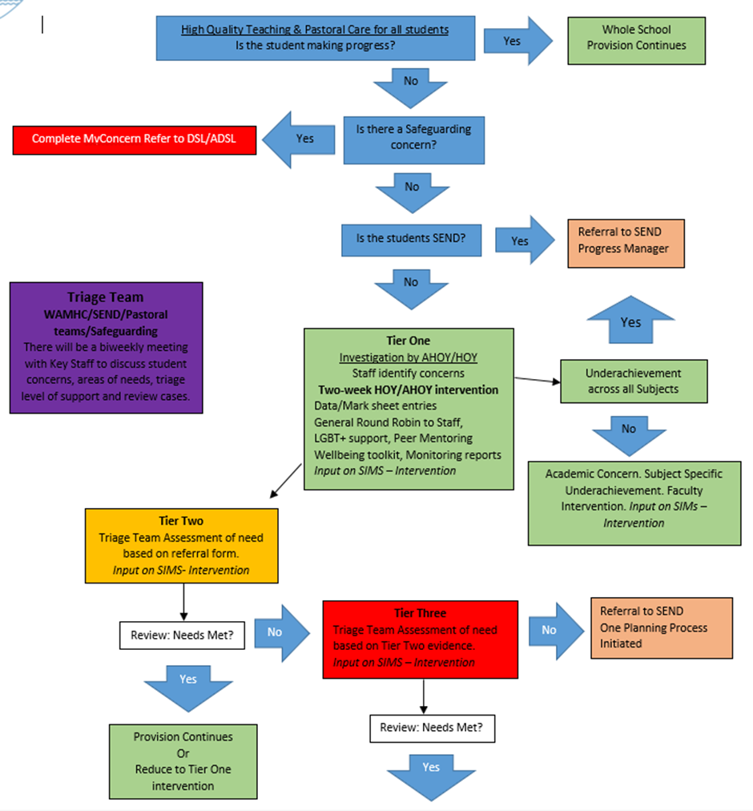
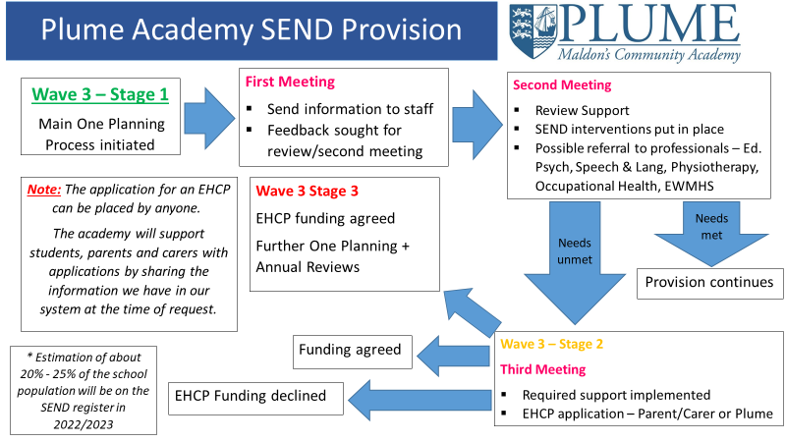

Question: 5 How do you differentiate between health or education interventions?
Unit: Recognising Common Mental Health Difficulties in Others | Assessment Criterion: 5.2
Health and Educational needs are intertwined and can have an impact on each other and can also be very separate. An Educational need reflects a learning difficulty which could be around cognition and is a barrier for learning. A health needs could be a medical condition/diagnosis that could affect their ability to access the learning, for example a deaf student would need adjustments made to be able to access audible learning resources that a hearing student can access. A student with OCD will need support with access to school in regards to health.
A Student with ADHD may need Health and Educational support.
When looking at the support to offer a student it is important to not only taking into consideration their current difficulty but also develop a full picture of their needs. This will then support the team to decide as to whether a health or educational intervention is put in place. Question to consider could be:Does this student have a medical diagnosis? Are there already external services working with this student? Is this student on he SEND register?
As a mental health lead in school our role is not to make diagnosis and whiles we are not mental health professions we can still suggest strategies to support a young person.
We would use our SEND Academy provision (See question 4) to identify the further educational support needs and look to refer for medical support, whist signposting to parents how to access medical support through their GP.

Educational psychologists  School | Clinical psychologists  Psychiatrists  Medical

Question: 6 Reflect on some examples of how you have chosen the most appropriate statutory or independent mental health service for a young person and how you referred to or accessed them.
Unit: Recognising Common Mental Health Difficulties in Others | Assessment Criterion: 5.2
Service | Referral process | Appropriateness | Threshold  Pros & Cons
NHS Silver Cloud  Cognitive Behavioural Therapy (CBT) via online platform | Online self-referral | Worked well for young people that was motivated my self-guided tools.  Covers Stress/depression/Anxiety and has a wellbeing questionnaire to help identify support needed | Low level wellbeing concerns only.  Feedback is given by a MH practitioner.  Free
Southend, Essex and Thurrock Children's and Adolescent's Mental Health Service (SET CAMHS) | Referral form can be completed by child, parent, careers or professional/teacher | Higher level of intervention with more options, including: CBT (Cognitive Behavioural Therapy)  DBT (Dialectical Behavioural therapy)  Trauma focused therapies  Play based therapies  Art and creative therapies  Psycho-dynamic therapy  Family therapy  Group Therapy  Medication  Worked well with students are higher risk including self-harm and suicide idolisation | Very long waiting lists so mental health can decline while on waiting list  Free
Kooth | Online self-referral | Work well for student as a first point of contact, and step to support wellbeing. | Accessible, timely support  Free
MHST | Self-Referral form submitted by school staff | We have been fortunate to have many student receive the support from the MHST practitioner  Support low mood, anxiety, phobias. 1:1 or groups. We had a very successful group for year 7 student suffering with anxiety and the outcomes were excellent. | Low provision  Staffing issues effecting service provision  Working in school  Free

Question: 7 Describe the various methods for monitoring the impact of interventions (individual or group) and how you can adapt approaches as needed.
Unit: Recognising Common Mental Health Difficulties in Others |  | Assessment Criterion: 5.3
There are various methods of monitoring the impact of interventions. Within my role I am using the screening of data such as Bullying Incidents, using this data I can understand the whole academy setting needs and where the support needs to be implemented. Collecting this data over the course of a few weeks, a term, a year or even a few years can build a detailed pictures as to the impact antibullying initiative had made. We adapted our Anti-bullying provision when rates of bullying increased and trained student anti bullying ambassadors.
As an academy we regularly screen and track the attendance, attainment, Progress & exclusions data to support gain a whole academy picture of these key areas. We can also track this against the national picture to see the impact of our whole academy provision.
There are many methods for tracking data to monitor the effectiveness of interventions or the effectiveness of a provision, for example the use of Wellbeing and social emotional resilience Surveys, SDQ\ Warwick and Edinburgh surveys. We have developed these by using the RCADS – CRC website to develop evidence-based tracking tools.
There are additional tools that as an academy we could look into using to monitor the interventions in place and these could need to be reviewed to see if they are fit for our setting and whether the cost. For example, Boxall Assessment tool for social emotional and behavioural difficulties for children and young people. – Cost 45p per students and can be time consuming. Satch One Wellbeing culture and climate tracking tool, Thrive online. Many of these are aimed toward primary setting and would need a lot of adapting to make them work for Academy.

Question: 8 How do you assess need and monitor progress?
Unit: Meeting the Responsibilities Placed on an Education Mental Health Lead |  | Assessment Criterion: 1.3
There are many methods of assessing need and monitoring progress, for example the use of Wellbeing and social emotional resilience Surveys, SDQ\ Warwick and Edinburgh surveys. We have developed these by using the RCADS – CRC website to develop evidence-based tracking tools.
See example blow from MHST student case study:
At the start of the treatment, CB symptoms of Social Phobia, Major depression, Separation Anxiety, Generalised Anxiety and overall scores (shown below) were elevated.

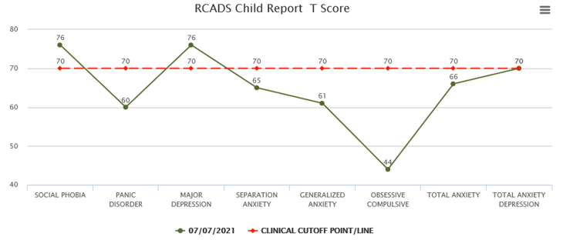
By the end of treatment all of CB symptoms had reduced considerably (shown below) with all scores now showing below the clinical cut off point.
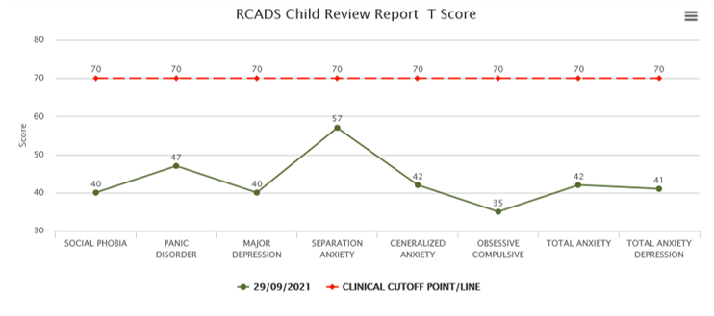

Our staff Pulse surveys are linked to our ‘Investors in People awards’ which help use as an academy to keep up to business standard our staff and we have just been awarded the Silver standard for this. We are on track to reach Gold by next academic year.
Benchmarking our progress against
Pulse Staff & Student surveys – Using evidence biased assessment benchmarks such as the Staff Wellbeing charter

Question: 9 Give an example of how feedback from or given to staff, pupils and parents helped a pupil access the support they required. Describe how this helped them engage in all aspects of school/college life and participate in lessons and extra-curricular activities.
Unit: Recognising Common Mental Health Difficulties in Others | Assessment Criterion: 5.4
Mental Health Support offered to a year 8 student based on feedback from Parent and Assistant Head of Year (AHOY)
CB experiencing some anxiety which was impacting their mood. CB explained that at times they felt so anxious that you would leave lessons and found it hard to ask for help when they didn’t understand the work that had been set. CB requested support to help manage anxieties and worries.
Up until this point they had be receiving Pastoral Support from AHOY: X anonymous. Concerns over attendance and progress. A meeting was held to establish a full picture of feedback from the AHOY, CB and Parents. Feedback from teaching staff was requested and help to build a full picture of concerns on progress and enjoyment. All this feedback help the academy based Triage team to ascertain the best route for support.
A Mental Health Support Team (MHST) referral was made.
CB attended six sessions of worry management support and MHST provided an extra session before CB return to school in September to look at transitioning to Year 9 at the Fambridge Road campus. CB worked hard on understanding their emotions and the effect that this was having on their thoughts, behaviours and body. CB reported no current concerns about risk. This was revisited regularly and did not change throughout. Over the six sessions MHST were able to build a clearer picture of what was happening for CB and how to use techniques to look at worries, recognise if CB was able to do something to solve these and use the appropriate techniques for managing these. CB set a goal of asking for help in lessons and reported that this was at a level of 0 at the start of our work together. During the six sessions CB reported that they had been able to ask for support and have practical conversations with teachers about what might help. At the end of the interventions CB rated this goal at a 9 on the scale and shared that they felt more confident to ask without feeling anxious.
MHST used the Revised Children’s Anxiety and Depression Scale (RCADS) which measures symptoms of anxiety, depression and low mood. (See Question 8)
Following this intervention CB was able use the support offered by MHST to make effective progress that directly impacted their wellbeing, their attendance improved and based on recent feedback they are making exceptional progress in their studies. CD is now looking to develop their role within the school and wishes to become a lead student.
Factors that made this a successful case were that the referral were made in a timely manner, the provision was able to support almost immediately, and the student was keen to make improvements. If any of these factors had not been in place, then the support would not have been as effective.

Part 8 Targeted Support
Question: 1 I Summarise common mental health issues in your setting by identifying the common symptoms of each and what services/professionals could offer support for each.
Unit: Recognising Common Mental Health Difficulties in Others | Assessment Criterion: 2.1
The mental health difficulties below are all common in my setting however the most common difficulty in Anxiety- Anxiety related mental health issues are evident in all year groups and with staff
Common Mental Health difficulty | Common Symptoms | Professionals that could support
Low Mood | Feeling sad, tired and lacking energy, unable to sleep, anxious, low self-esteem and confidence. | Mental Health Support Teams (MHST)  County Child & Family Wellbeing Service  SHOUT  Childline  Multi-disciplinary teams
Anxiety | Low confidence, low appetite. Feeling overwhelmed, full of dread, panicky all the time. Feeling tired and grumpy. Physically shaking, trembling, or having wobbly legs. Panic Attacks. | Mental Health Support Teams (MHST)  County Child & Family Wellbeing Service  SHOUT  Childline  Multi-disciplinary teams  Educational psychologists
Eating disorders including Anorexia Nervosa & bulimia | Body dysmorphia, withholding, restricting food intake. Withdrawn, low self-esteem. Food binges, followed by vomiting and taking laxatives. | NHS GP  BEAT  Multi-disciplinary teams
Self-harm | Cutting, burning, hitting, picking, pulling hair/skin, sexual promiscuity, alcohol/drug misuses | NHS GP  CAMHS  CBT/Talk Therapy  Counselling
OCD -obsessive compulsive disorder | Obsessions – unwanted intrusive thoughts, emotions - causing anxiety and distress and compulsions-respective mental or behavioural acts | NHS GP Medication  CAMHS  CBT/ exposure and response therapy.

Question: 2 Analyse the importance of signposting and referral to appropriate services and reflect on what stage you refer a pupil for mental health specialist services.
Unit: Recognising Common Mental Health Difficulties in Others | Assessment Criterion: 4.2
As you will see from my self study I value mental health signposting and feel that it is one of the most important of the whole academy mental health culture and ethos. Signposting empowers others to tools to self refer or access guided self help tools for when they need them. As referrels can be completed by the individuls, their peers, parents and/or staff it is inportant that our routes to referrals are cleary signposted to all. We offer singposting in every Personal development lesson, tutor time and assembly so that all students are aware of how to seek support. Our pastorial teams make tier 2 and 3 referrels and they receive in acadmy training sharing best practice on how to reffer as well at attending external servicces inofmration webenars and training. I have developed a clear Tier system that supports our signposting and referrals. Please see the infograthic below:
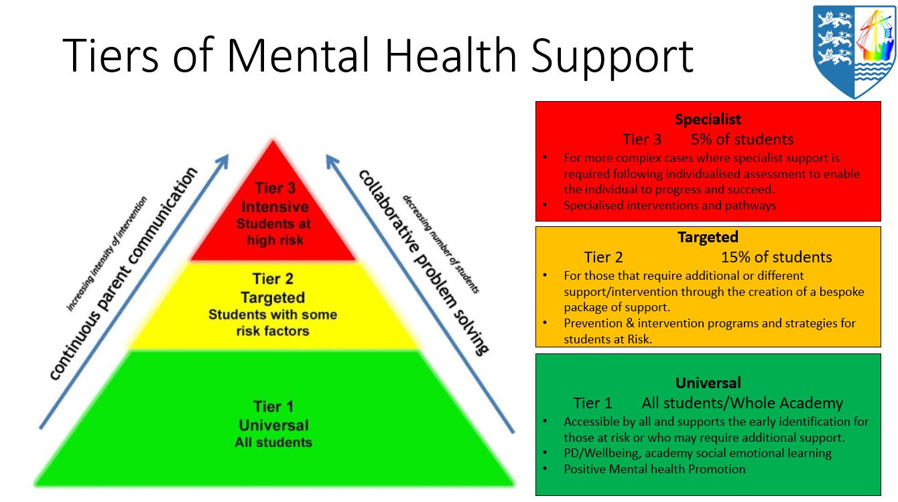

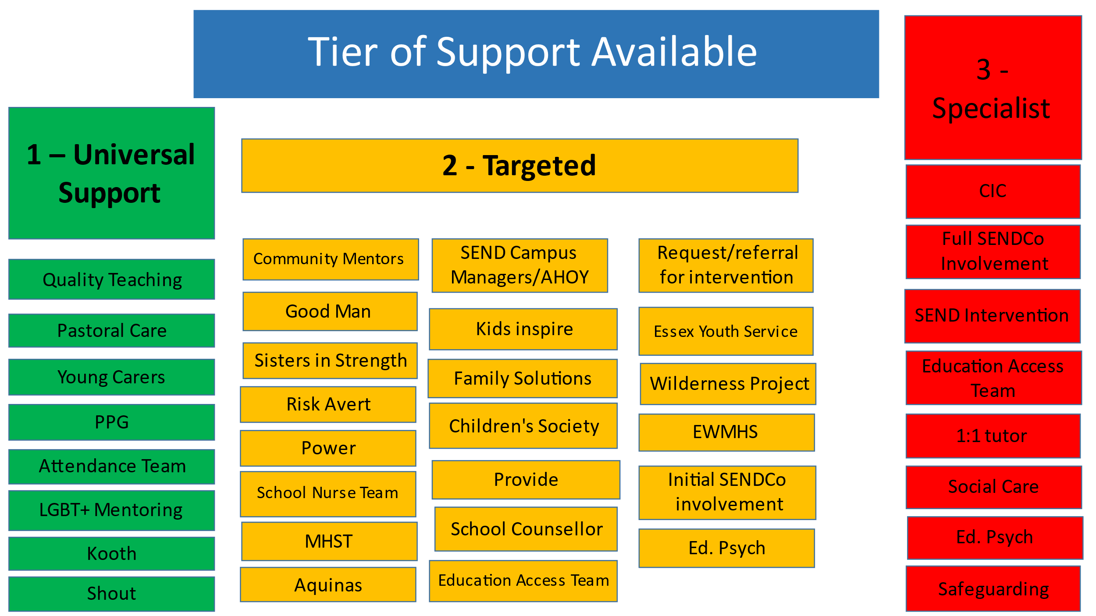
In addition to this infographic, I have developed a clear flow chart that clearly identifies the teirs of support and at what point students should be escalated or de-escalated for support. There is a real focus on communication and record keeping in our route of referral as we believe that staff should be well informed as to the progress of referral and outcome.

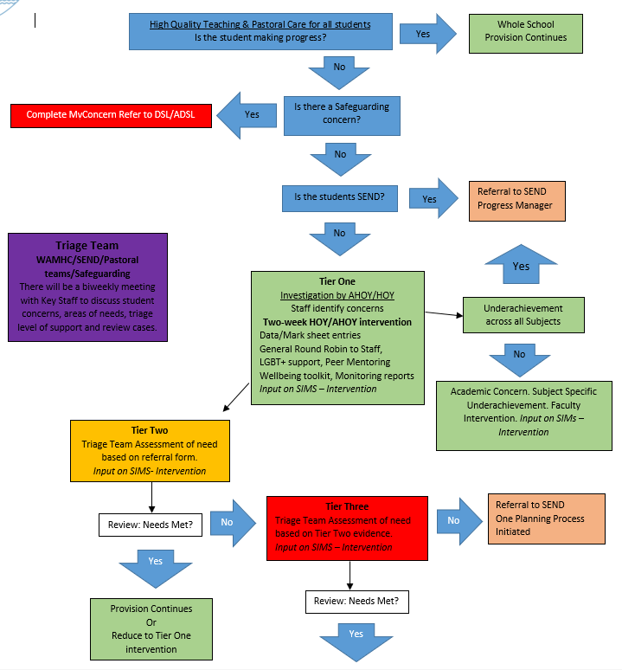

Part 9 Curriculum, Teaching and Learning
Question: 1 Reflect on the links between different aspects of health, such as physical and mental, and how you are promoting this across the organisation.
Unit: Meeting the Responsibilities Placed on an Education Mental Health Lead | Assessment Criterion: 2.2
Our intention is to enable our students to make well-informed and positive choices regarding health and wellbeing, so it is essential we are building on the provision they received at their primary setting. Understanding what is taught in these settings through primary visits during transition, and baseline assessments via surveys in their Personal Development lesson helps us pitch our programmes of study at the right levels and adapt signposting to support the cohorts needs. This was particularly important post covid where there had been dramatic gaps in students’ health and wellbeing education due to time missing from the classroom. This also meant they we had to adapt out SRE programme to ensure that statutory requirements are meet for these students.
We currently make the links between health and wellbeing in the following areas
Personal Development Programme – Year 7,8 &9 have 1 timetabled curriculum hour each week.
Tutorial Programme – All year groups have additional PD session during tutor time
Assemblies – two assemblies are delivered each week and focus on PD related topics.
During these sessions our bespoke PD curriculum highlights the relationship between good physical health and good mental health can impact their ability to learn and combat stress. Offers steps to protect their physical and wellbeing through education on the associated ricks of using drugs, alcohol and tobacco. Highlights the importance of spending time outdoors, sufficient sleeps, good nutrition and resilience building strategies. We offer first aid to all students, workshops on health and hygiene. Our SRE is fully developed and covers units on understanding the physical and emotional changes, which take place at puberty and the impact these have on their wider health and wellbeing. We offer free sanatory products to all students which continues to prompt our commitment to health and wellbeing.
As part of my SMART targets, I plan to develop the health and wellbeing content across the academy through curriculum time and especially would like to make links with the Physical education department to run physical wellbeing activities. Such as
https://www.gov.uk/guidance/teaching-about-mental-wellbeing
https://www.gov.uk/government/publications/relationships-education-relationships-and-sex-education-rse-and-health-education/physical-health-and-mental-wellbeing-primary-and-secondary
10/2/23 When reflecting on the links between different aspects of health it is important to consider that those who have poor physical health are likely to have poor mental health. So when support an student who is returning to the academy following a period of medical related absences it is important to consider support around there transition into the building in both a physical and mental health way. Will they need support around managing feeling and time out when feeling overwhelmed? Out SEND faculty use the OPPs to outline both physical and mental health needs. This is also factored into the pastoral support meetings which take place across the academy. Our HR staff also take this into consideration when support colleagues who are physically unwell and the support around this as to assessing mental health support in the form of Mental Health First Aiders and the Educational Partnership programmes.

Question: 2 Describe how you are supporting the development of a cross-curricular approach to the mental health and wellbeing curriculum.
Unit: Meeting the Responsibilities Placed on an Education Mental Health Lead | Assessment Criterion: 2.3
Development Need 4 With subject leads, developing a cross curricular approach to mental health and wellbeing. | SMART To meet with Faulty leads to support the implantation of Cross curriculum mental health for X family Wellbeing Week 2022/2022
My future aim to develop the cross curricular approach towards mental health, this will be via coproduction of the Personal Development Curriculum with students and key colleagues to ensure that it is age appropriate, utilises up to date knowledge and information and enables students to effectively improve their mental health and wellbeing through practical strategies and tools. This is a big project, so I have saved this for the new academic year, my first year in post was about quick wins, visibility and destigmatising mental health.

There have been a few ways that I have supported the development of a cross-curricular approach. For example, though the development and implementation of termly Whole academy X Family Wellbeing Weeks, these weeks are in line with the national awareness campaigns:
  - World mental health Day – October https://wmhdofficial.com/
  - Children’s Mental Health Week -Place2be - February https://www.place2be.org.uk/about-us/children-s-mental-health-week/
  - Mental health awareness Week – Mental Health foundation & Mental Health UK – May
During these weeks we take over the Tutor time, Personal development and assembly curriculum time and use themes resources to educate our students on mental health and wellbeing. Out teacher adapt lesson starters and actives to match the weeks’ theme so that student can identify the links in health, wellbeing across the curriculum.
My role within these weeks in to coordinating the activates ensure that all stakeholders understand their roles, providing quality resources to Head of years for their assemblies, sharing lesson ideas and resources with faculty leads and liaising with our libraries so that topical reading lists can be created. I also support the awareness of these weeks through letters to parents/careers signposting support available to them and their families and celebrate the outcome of the work completing across the curriculum throughout X Newsletter and website.

Evidence Tracking

Evidence Tracking
When you have finished the portfolio, please complete this table to link the qualification criteria to your answers.

Learner Name: | Anonymous
Tutor/Assessor Name (we complete):
Qualification Title: | 1234567 – Mental Health Aware Leadership (Education Mental Health Lead)

Unit Title | J/618/1356 – Supporting Wellbeing in own Organisation
Learning Outcome |  | Assessment Criteria | Evidence / Task | Page No. | Date completed
1. Understand their role in contributing towards the mental health and wellbeing of their staff (and service users if appropriate) |  | 1.1 Review the importance of a mental health friendly manager or leader in contributing to culture and ethos | Part 1 Question 1 | 12 | 22.feb
 |  | 1.2 Reflect on the qualities of a mental health friendly manager or leader | Part 1 Question 2 | 13 | 22. feb
 |  | 1.3 Identify own developmental needs and actions they can take to address these needs | Part 1 Question 3 | 14 | 22. feb
2. Understand the priorities of mental health and wellbeing within their organisation |  | 2.1 Participate in or undertake a review of mental health and wellbeing in their organisation/team | Audit | Attached | 22 feb
 |  | 2.2 Produce an action plan for the priorities of mental health and wellbeing in their organisation/team | Action plan | Attached | 22.feb
 |  | 2.3 Assess the impact of any changes they have made | Part 1 Question 4 | 15 | 22. feb
3. Understand how individuals, services and partner organisations may contribute to the culture and wellbeing of their staff |  | 3.1 Review the role of colleagues, services or potential partner organisations that could contribute towards the culture or wellbeing of staff and service users if appropriate | Part 6 Question 1 | 33 | 26. April
 |  | 3.2 Reflect on how they work with others to improve and sustain their approach | Part 1 Question 5 | 16 | 22.feb

Unit Title | T/618/8156 – Meeting the Responsibilities Placed on an Education Mental Health Lead
Learning Outcome |  | Assessment Criteria | Evidence / Task | Page No. | Date completed
1. Understand the requirements on own organisation relating to mental health and wellbeing |  | 1.1 Assess the risk of emotionally demanding roles within own organisation | Part 6 Question 8 | 42,43,44 | 2.march
 |  | 1.2 Describe own organisational plan for delivering and monitoring staff training | Part 6 Question 7 | 41 | 2.march
 |  | 1.3 Recount how own organisation assesses need and monitors progress relating to mental health and wellbeing | Part 7 Question 8 | 52 | 26.april
2. Understand the role of mental health leaders in own educational setting |  | 2.1 Review the role of mental health leaders and champions in own education setting | Part 1 Question 6 | 17-18 | 22.feb
 |  | 2.2 Reflect on the links between different aspects of health, such as physical and mental, and how to promote this across the organisation | Part 9 Question 1 | 58 | 26.april  10/2/23
 |  | 2.3 Provide examples of how own setting provides a cross-subject curriculum | Part 9 Question 2 | 59 | 26.april
 |  | 2.4 Reflect on working with others to connect policies and procedures | Part 2 Question 3 | 22 | 22.feb
3. Understand how to engage with pupils, parents and carers and the wider community |  | 3.1 Reflect on developing positive working relationships with parents and carers from a range of backgrounds | Part 5 Question 1 | 31-32 | 2.march  10/2/23
 |  | 3.2 Describe the process of co-producing and co-reviewing a whole-setting approach (provision, policy or resource) with all sectors of the pupil body, families and partner services (such as virtual schools and care) | Part 4 Question 1 | 27 -29 | 2.march  10/2/23
 |  | 3.3 Describe how to support pupils to help each other and provide peer-led support | Part 4 Question 2 | 29 | 2.march
 |  | 3.4 Give examples of working in partnership with parents, carers, virtual schools and the local community to promote a wellbeing culture appropriate for in and out of school settings | Part 2 Question 4 | 23 | 22.feb
 |  | 3.5 Recount examples of supporting/signposting to evidence-based resources to help parents and carers develop their in supporting their child | Part 5 Question 2 | 32 | 3.march
 |  | 3.6 Reflect on how to build stronger links with statutory and independent mental health services, such as supporting them to shape their offering | Part 3 Question 3 | 26 | 2.march

Unit Title | F/618/1355 – The Role of a Leader in Contributing Towards the Mental Health of Others
Learning Outcome |  | Assessment Criteria | Evidence / Task | Page No. | Date completed
1. Understand how their values, beliefs and attitude contribute towards a mental health friendly ethos |  | 1.1 Identify own values and attitudes towards mental health, including factors that may contribute towards these | Part 2 Question 1 | 18-19 | 22.feb
 |  | 1.2 Give an example of how they have previously demonstrated an open and empathetic approach to understanding fluctuations of mental health | Part 2 Question 2 | 21 | 22.feb
2. Understand the role of stigma and bias in people’s responses to poor mental health |  | 2.1 Identify a range of stigmas and biases that may relate to people's response to poor mental health | Part 3 Question 1 | 24 | 2.march
 |  | 2.2 Recount how stigma and bias have affected someone’s response to the culture or poor mental health | Part 3 Question 1 | 24 | 2.march
 |  | 2.3 Identify actions that can be taken to tackle stigma or bias towards mental health in their environment, including the role of key stakeholders | Part 3 Question 2 | 25 | 2.march
3. Understand activities or resources that contribute towards people’s mental health |  | 3.1 Reflect on how mental health leaders support their own mental health | Part 6 Question 4 | 36 | 26.aril
 |  | 3.2 Identify evidence-based resources or sources of information that can support the mental health awareness of staff | Part 6 Question 5 | 37-38 | 26.april
 |  | 3.3 Describe simple strategies or exercises to support people’s coping strategies or wellbeing | Part 6 Question 6 | 39 | 26.april  10/2/23

Unit Title | R/618/1358 – Recognising Common Mental Health Difficulties in Others
Learning Outcome |  | Assessment Criteria | Evidence / Task | Page No. | Date completed
1. Understand common factors that affect mental health |  | 1.1 Analyse common factors that can affect mental health, such as life events, risks, and factors in the environment | Part 7 Question 1 | 45 | 26.april
2. Understand common mental health difficulties in their environment |  | 2.1 Summarise common mental health difficulties in their environment | Part 8 Question 1 | 55 | 26.april
3. Understand the role of emotions in mental health |  | 3.1 Summarise the symptoms of someone in their environment who may be emotionally overwhelmed or in distress. | Part 6 Question 2 | 34 | 2.march
 |  | 3.2 Describe common emotional coping mechanisms and factors that may affect a person’s ability to access them | Part 6 Question 3 | 35 | 2.march
4. Know how to support someone experiencing poor mental health within the context of their role |  | 4.1 Describe initial actions that could be taken in their role to support someone experiencing poor mental health | Part 7 Question 3 | 47 | 26.april
 |  | 4.2 Analyse the importance of signposting and referral to appropriate services | Part 8 Question 2 | 56-57 | 26.april
5. Understand support available for those experiencing poor mental health |  | 5.1 Describe different ways of identifying those in need, including the use of pre-existing documents | Part 7 Question 4 | 48 | 26.april
 |  | 5.2 Reflect on services that will offer assistance to their staff, and service users if appropriate, who are experiencing poor mental health and how to refer/access them | Part 7 Question 6 | 50 | 26.april
 |  | 5.3 Reflect on how to monitor the impact of support or interventions offered to people experiencing difficulties | Part 7 Question 7 | 51 | 26.april
 |  | 5.4 Give an example of working with others in their environment to support someone to participate successfully in the environment | Part 7 Question 9 | 54 | 26.apil

Unit Title | L/618/1357 - Researching a Mental Health Leadership Topic
Learning Outcome |  | Assessment Criteria | Evidence / Task | Page No. | Date completed
1. Undertake their own research into a mental health topic relevant to their role |  | 1.1 Analyse their selection of a topic and how it links to their workplace. | Self-study Question 1 | 3 | 14.sep
 |  | 1.2 Select a variety of appropriate resources and reference materials related to the topic. | Self-study Question 2 | 4-5 | 14.sep
 |  | 1.3 Present the outcomes of this research and how it links to people’s wellbeing. | Self-study Question 3 | 6 | 14.sep
2. Apply the outcomes of their research to their role |  | 2.1 Link the outcomes of their research to their role. | Self-study Question 4 | 7 | 14.sep
 |  | 2.2 Identify actions they intend to take as a result of their research. | Self-study Question 5 | 8,9,10,11 | 14.sep
3. Reflect on the impact of their research application |  | 3.1 Analyse the changes they were able to make as a result of their research. | Self-study Question 5 | 8,9,10,11 | 14.sep
 |  | 3.2 Reflect on the impact of these changes to others’ wellbeing. | Self-study Question 5 | 8,9,10,11 | 14.sep

Unit Title | Department for Education specific outcomes
Learning Outcome |  | Evidence / Task | Specific feedback  (grades are provided for feedback purposes only)
Work with staff, families and local services to understand the mental health and wellbeing issues that could be impacting on behaviour and attendance to improve outcomes for pupils/students, and ensure that all school policies reflect this. |  | Part 7 Question 2 | Page 46
Make a decision about whether a health or education intervention is more appropriate and access this support with reference to the Local Offer. |  | Part 7 Question 5 | Page 49

Learner Signature: | Anonymous | Date: | 14.09.22  10.2.23
Tutor/Assessor Signature: |  | Date:

All information provided on this form will be held securely on the databases of The Root Of It and Open Awards and only used for the purposes provided. Full details on how we use and protect your data are available in on our Data Protection Policy or Open Award’s Privacy Notice.

The Mental Health Awareness Programme and Open Awards tries to meet the highest standards when collecting and using personal information. Customers are encouraged to email info@rootofit.com if you believe any data to be incorrect, unfair, misleading or inappropriate.

